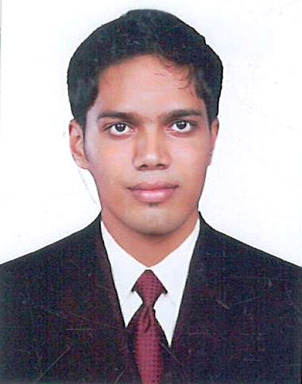
HAMID (BCA, MCSA)
C/o-Ph no: +971502360357

Email id: hamid.343229@2freemail.com

Seeking a responsible and challenging career in IT industry to further drive my acquired academic knowledge and interest in a benefit of the organization and in turn enhance my professional skill and capabilities.

1YEARS OF EXPERIENCE IN DESKTOP SUPPORT ENGINEER&ADMINISTRATIVE ASSISTANT
CAREER CONTOUR

AIHT Pvt Ltd,BANGALORE
www.asnait.com
Desktop Support Engineer
JUNE-2014 to JUNE-2015

- Maintaining 2003, 2008 and 2012 domain controllers.
- Support for organization enduser laptops, desktops, servers, mobile devices and applications using WINDOWS system.
- Responsible for maintaining the day to day operation related to MS Windows Servers, AD, DNS, DHCP, Group Policy etc.
- Installs and maintains operating systems and third party applications
- Network Troubleshooting the Basic Network Issues.
- Solve H/W S/W related printer issues.
- Solve bank server basic issues.
- Troubleshooting laptops and desktops through team viewer.
- Relevant Experience in VMware.
- Also worked as a office administrator.
- Support the following technologies: Microsoft Office 2007 products – Outlook, Word, Excel, Access, Internet Explorer, Windows XP, desktops, laptops, printers
- Installs and maintains operating systems and third party applications
- Installing & Configuration of Troubleshooting S/W and H/W problems

CONCORD ICE CREAM CENTRE
System Admin cum Driver
April-2015 to September-2015
- Installing & Maintaining of windows XP, Professional and windows 7,8 and10.
- Installing & Configuration of Troubleshooting S/W and H/W problems.
- Support the following technologies: Microsoft Office 2007 products – Outlook, Word, Excel, Access, Internet Explorer, Windows XP, desktops, laptops, printers
- PC assembling
- Managing Data Backups and Restores.
- Maintaining and troubleshooting of desktop PC’s. Attending user calls.
- Network Troubleshooting the Basic Network Issues.

TECHNICAL TRAINING

- Windows Server 2012 Certified (MCSA)
- Computer Hardware and Networking from AIHT
- Cisco Certified Network Administrator(CCNA)

ACADEMIC QUALIFICATION

- Bachelor Of Computer Application From Pilathara Co Operative Arts & Science College,
With 55% Aggregate, Affiliated To Kannur University, Kannur.
- Plus Two Science from GBHSS, Madayi Kannur, India, With 68 % Aggregate.

KEY SKILLS:
- Excellent Communication Skills – Spoken & Written.
- Capability to Work efficiently in a team or in an independent environment.
- Ability to work efficiently under pressure.
- Efficient in achieving targets in the given timetable.

CERTIFICATIONS

- MICROSOFT CERTIFIED SOLUTION ASSOCIATE: WINDOWS SERVER 2012
- CLOUDU CERTIFIED BY RACKSPACE
- BACKUP ACADEMY CERTIFIED PROFESSIONAL
- COMPUTER HARDWARE (A+)
- COMPUTER NETWORK (N+)
- IPV6 CERTIFICATION
PERSONAL DETAILS

Age &Date of Birth : 24,01st September 1992
Visa Status : Visit Visa
Nationality : Indian
Religion & Caste : Islam, Muslim
Marital Status : Single
Languages Known : English, Hindi and Malayalam

DECLARATION

I hereby declare that the information given above are true and correct to the best of my knowledge and belief.
HAMID

