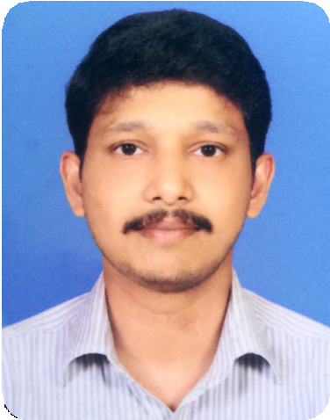

JILSON
JILSON.343239@2freemail.com

About Me
I am an enthusiastic and hands-on IT professional with more than 10 years of experience. My track record of managing and maintaining Servers, VMWare, Mac and Desktops in LAN/WAN network infrastructures is complemented by a meticulous approach to smooth-running business operations. Qualified to industry standards, I closely track the latest technologies and apply them to my
duties wherever possible.
educational qualification
B.A (English Literature) from S.D College Alappuzha (University of Kerala), Kerala, India
Pre-Degree (Maths with Science Group) from SD College
Alappuzha (University of Kerala), Kerala, India
S.S.L.C from Govt. Model High School, Trivandrum
Kerala (Kerala State Board of Public Examinations), India
other qualifications
Diploma in Advanced Multimedia
Diploma in Electronics Instrumentation Govt. Polytechnic, Cherthala, Kerala, India

My Experiance
operating system used
Mac OSX, Windows, Windows Server 2003, 2008 & 2012 R2
skill set
Networking Knowledge:
VMWare vSphere, Server Backup, Experience with MS Office Packaged and Mail Clients, Good Idea about Active directory, DNS and DHCP,
E-Mail Client Configuration & Support. LAN/WAN technology, Trend Micro
Interscan Messaging Security Suit (IMSS) & Antivirus Software.
professional experiance
Worked as an IT Engineer with M/S Adventure, Cochin, Kerala,
India, from February 2005 to January 2009.
Worked as an IT Engineer with M/S Amazing Advertising,
Manama, Bahrain, from March 2009 to March 2011.

My Experiance
professional experiance
Worked as an IT Manger with M/S Gulf Marcom, Manama, Bahrain from April 2011 to August 2016.
Duties & Responsibilities:
- VMWare vSphere Server Configuration
- Install, Configure, and maintain Network Services, Equipment and devices
- Troubleshooting for Network Related Issues
- Manage user accounts, permissions, email, Anti-virus, Anti-spam
- Troubleshooting analysis of the Modems and Routers
- Manage Wireless Connectivity by setting the Channel, SSID and Security
- Had been Responsible in monitoring the network performance
- Worked on Routers like Cisco, Linksys & Netgear
- Servers, Mac & Windows Daily Backups
- OS & Software Installation of Mac, Windows & Servers
- Renewals for Webhosting & Domains

Declaration:
I hereby declare that all the above mentioned details are true and correct to the best of my knowledge and belief.
My Profile

