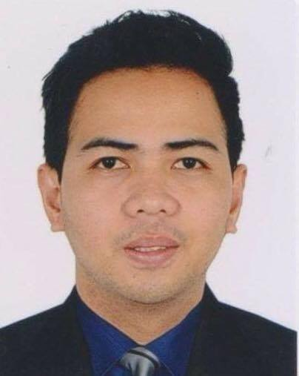
Joeli
Email Address: joeli.343253@2freemail.com
C/o-Contact Number: +971503718643

Career Objectives
To seek a dynamic and challenging career in a organization for making a positive contribution towards the organization, and to find an environment where I can maximize my professional knowledge and Interpersonal skills for mutual benefits of the organization and to myself.

Professional Experience
- A self-motivated professional.
- Skilled at balancing and prioritizing multiple task to meet deadline.
- Highly organized and able to prioritize effectively-detailed-oriented.
- Strong verbal communication skills and good personality.
- Hardworking, Flexible, adapt easily to change of environment and work schedule.
- Can work with minimal supervision
- Promote good working environment with my colleagues.

Professional Work Experience

Syllabus Inc,(Franchise Holder of STI College San Fernando and STI Angeles)
Laboratory Facilitator/Trainor
City of San Fernando, Pampanga,Philippines
June 23,2010- January 10,2017

Duties and Responsibility
- Facilitate/train hospitality students during their actual classes in culinary(e.g Proper Handling of Knife, basic cutting techniques, preparation of stocks and sauces, preparation of mise en placeof dishes appetizer to dessert, proper food handling to avoid contamination,storing of food and perform safety and sanitation in kitchen laboratory.)
- Responsible to train students the proper etiquette in the kitchen area.
- Responsible for assisting hospitality during their competition in cooking
- Responsible for giving idea with new trends in hospitality industry
- Facilitate students during their culminating activities such as Function events.
- Responsible for giving actual demonstration in culinary arts classes
- Keep an updated list of inventory of all the materials and supplies and equipment in the HRM department.
- Responsible for requesting annual renovation of laboratory facilities for convenient of the students during their actual classes.
- Responsible for maintaining the cleanliness of laboratory facilities ,equipment and materials at the end of every session.
- Perform related task assigned of my immediate supervisor

Bliss Hotel- Part time
Food and Beverage Personnel
17-22 Lazatin Blvd. Dolores, City of San Fernando, Pampanga,Philippines
January 18, 2014-April 1, 2014

Duties and Responsibilities
- Responsible for taking guest order.
- Responsible for guest service Restaurant and Hotel Facility
- Responsible for setting up event hall for the upcoming events such as wedding, anniversary, birthday seminars etc.
- Responsible for taking good care of Food and Beverage facility for the convenient of the guest.
- Responsible to make an starting inventory and ending inventory of restaurant supplies during shift
- Responsible for requesting of restaurant supplies in the purchasing department
- Assist the restaurant supervisor for making an report/presentation with the upcoming event.
- Facilitate the restaurant during the absence of the restaurant supervisor and employee.
- Help colleagues to achieve the set goal of the Food and Beverage Department.

King’s Royal and Leisure Park
Food and Beverage Personel
Makabakle, Bacolor, Pampanga,Philippines
March 10, 2010-June 10, 2010

Duties and Responsibilities
- Responsible for taking guest food order
- Responsible for guest service Restaurant and Hotel Facility
- Responsible for setting Functional Hall for the upcoming events. e.g conference and seminars, wedding, birthday and any occasions.
- Responsible for requesting Food and Beverage supplies in the Storage Room for refreshment of supplies.

Qualifications/ National Certification

- Bartending National Certificate Level II
Technical Education Skills and Development Authority (TESDA)
March 23,2013

- Food and Beverages Services National Certificate Level II
Technical Education Skills and Development Authority (TESDA)
March 8, 2013

- Commercial Cooking National Certificate Level II
Technical Education Skills and Development Authority (TESDA)
May 27, 2010

Training and Seminars
- Basic Disaster and Preparedness Training Program
STI College City of San Fernando, Pampanga, Philippines
January 10, 2014

- Coffee Seminar and Latest Trends in Hospitality Industry
TGIF Marquee Mall, Angeles City, Philippines
October 22, 2012

- Basic Bartending Workshop
STI College City of San Fernando, Pampanga, Philippines
May 16-20, 2011

- Fruit and Vegetable Carving Workshop
STI College City of San Fernando, Pampanga,Philippines
May 16-20,2011

- The 15th STI National Youth Convention “Simulan Natin”
Camp John Hay, Baguio City, Philippines
December 4 ,2009

- Principle of Western and Asian Cuisine
STI College City of San Fernando, Pampanga, Philippines
October 9, 2009

- FLAIR TENDING
STI College City of San Fernando, Pampanga, Philippines
March 12, 2009

Educational Attainment

Tertiary Bachelor of Science in Hotel and Restaurant Management
STI College City of San Fernando, Pampanga
June 2012-May 2015

Hospitality and Restaurant Services
STI College City of San Fernando, Pampanga June 2008-April 2010

Personal Information

Date of Birth : August 23, 1991
Place of Birth : Macabebe, Pampanga
Gender : Male
Height : 5’5 1/2" ft
Weight : 120 lbs
Civil Status : Single
Nationality : Filipino

I hereby attest that the above information is true and correct in the best of my knowledge and belief.

