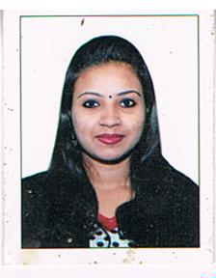
BIO DATA

Rajalakshmi

C/o-contact no: +971505891826

Email id: rajalakshmi.343256@2freemail.com

CAREER OBJECTIVE
To be an Degree in MBA(HR) seeking a challenging environment that encourages continuous learning and creativity. Providing exposure to new ideas that stimulate both professional and personal growth.

EDUCATIONAL QUALIFICATION

- Completed Post Graduation in MBA(HR) with 79 percent in 2015 from RMC College Palakkad.
- Completed graduation in BBM (CA) degree with 80 percent in 2012 from AJK college , COMBATURE
- completed HSE education since 2009 from HSS OTTAPALAM
- completed SSLC from Kattukulam hss with 72 percent since 2009

TECHNICAL EXPERIENCE

  - Worked as CCE in a reputed firm(DU INERNATIONAL PROCESS) from the date of 08.09.2015 to 08.09.2016
  - Worked as front office executive in a reputed firm from the date of 01.04.2013 to 30.05.2014.
SOFTWARE PROFICIENCY/ SKILL
Technical Software:

- MS OFFICE

SKILL & STRENGTH:-

- Loyality and dedication towards profession
- Quick perception and analysis skills
- Good communication & inter personal management Skill
- Quick learner
LANGUAGES KNOWN

English,Hindi,Malayalam,Tamil

PERSONAL PROFILE
Date of birth : 28/08/1991
Gender : FEMALE
Marital status : Married
Nationality : Indian

DECLARATION

I hereby declared that the information furnished above is true to the best of my knowledge and belief.

