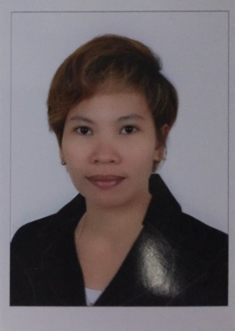C/o-Mobile no: +971505891826
Salve
Email: salve.343291@2freemail.com

I am seeking employment with a company where I can use my talents and skills to grow and expand the company while I experience advancement opportunities. And to excel in this field with hard work, perseverance and dedication.

PROFILE SUMMARY
- Good communication skills in English.
- Can handle multiple tasks effectively and very much flexible with time.
- Result driven, goal setter and achiever, motivated.
- Quality Oriented. Fast learner and very adaptable.
- Can operate Microsoft office.

- PCB Inspector
From 2012-2015
Innolux Corp.
Tainan, Taiwan

- Machine Operator
From 2015-2016
Crystalwise Technology
Hsinchu, Taiwan
Job Description

- Inspect Components, test and measures product.
- Complete the inspection and must analyze and interpret blueprints
- Looks for visual defects and appearance defects
- Making sure the good quality of the product.
- Reporting to the leader or supervisors if some error occur.

- Sales Lady
From 2011-2012
SM Department Store
Fairview Q. C. Philippines
Job Description
- Greet customers at the store and provide them with information on their required products
- Lead customers to desired shelves or aisles and assist them in locating products
- Explain product features and benefits by performing demonstrations and answer any questions that customers may have
- Provide information regarding prices and after sales services and ways in which the latter can be obtained
- Call existing customers to provide them with information on new products or discount options and markdowns
- Create sales reports, detailing all transactions made in a day for the purpose of informing the management of individual sales progress

- Caregiver
From 2007-2011
Family Home
Amman, Jordan

Job Description:

- Assist clients in addressing everyday personal needs such as toileting, bathing and grooming
- Perform light housekeeping activities such as cleaning, dusting and vacuuming
- Make beds on a daily basis and change linen as often as required
- Engage clients in physical and mental exercises prescribed by their doctors
- Provide companionship on a daily basis by lending an ear or a shoulder to lean on
- Prepare food or oversee the preparation of food to ensure that hygiene standards are met and that doctors’ orders are being followed
- Arrange medicines to be taken on schedule by providing appropriate reminders or administering medication only upon doctor’s orders
- Observe elderly for signs of deterioration or concern and report them to the family or doctor on an immediate basis

Date of Birth : July 06, 1983
Place of Birth : Puerto Princesa City, Palawan (PH)
Age : 33
Sex : Female
Civil Status : Single
Height : 5’4ft
Nationality : Filipino
Visa Status : Tourist Visa

