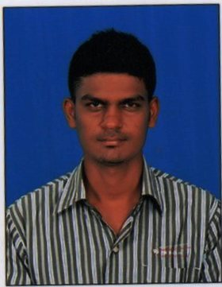
RESUME

PREM
Karama, dubai
C/o-Telephone: +971 505891826
Email: prem.343316@2freemail.com
Objective
To associate with vibrant organization which allows me to put my competencies to the best use and add value to the organization contributing to growth as an individual.
Personal Strength
- Communication Skills
- Confident
- Love to learn new things & detail conscious
Educational Qualification
- MBA in HR & Marketing with 70%
- BBA from Periyaruniversity with 65%
- HSC with State Board with 78%

Computer Skills MS Office & Internet

Employment Details
PROFESSIONAL EXPERIENCE
CLOB TECHNOLOGIES february 2016 to February 2017 asSenior HR executive.
HR Administrator
• Handle HR related documentation and records
• Act as the first point of contact for all human resource related activities
• Assist human resource managers during recruitment and induction procedures
• Create and maintain liaison with external recruitment agencies
• Coordinate in-house training activities and track training sessions
• Assist HR in performing background checks and reviewing references
• Coordinate interviews and direct applications to the right channels
HR Assistant
• Provided support to the recruitment and induction processes
• Handled personnel records and labor relations
• Performed job evaluations and handled benefits administration procedures
• Assisted in reviewing and entering data from human resource documentation
• Maintained liaison with prospective candidates
• Arranged interview schedules and followed up on candidates’ responses

Projects (Academic projects)
- “ EMPLOYEE WELFARE MEASUREMENTS” in clob technologies Coimbatore

Summer Internship
Organization: SAS AUTOMOBILE ENGINEERING
Period: 30 Days
Department: Human Resources
Project Title: Recruitment, Selection, Induction and retention
Work Content:
- Scheduling and conducting Preliminary interviews for labors and lower level management
- Handling of attendance records for wage payment
- HRIS data collection and data feeding
- Preparing monthly HR reports
- Explaining salary fitment to laborers
- Other admin activities
Extra Curricular Activities
- Participated in state level competition won the 2nd prize adzap in sns college of technology.
- Participated in state level competition won the 2nd prize adzap in kongunadu college
Personal Details
Date of Birth: 03.05.1992
Languages Known: English, Tamil
DECLARATION
I do hereby declare that the above-furnished information is true to the best of my knowledge.

