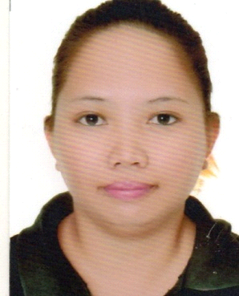Joanne
C/o- +971505891826
Joanne.343357@2freemail.com

PROFESSIONAL EXPERIENCE:

ADMINISTRATIVE OFFICER cum DIETETIC AIDE
Anthony’s Restaurant
Region 1 Medical Center Hospital
Dagupan City, Pangasinan Philippines
January 2016 – January 2017

Job Responsibilities:
Reports to the manager in charge and is responsible for assisting with preparation of financial statements, maintaining cash controls supervising the payroll and personnel administration, purchasing, maintaining accounts payable and managing office operations.Promote good dietary health and treat medical conditions by devising eating plans for patients based on the science of nutrition.

ADMINISTRATIVE OFFICER
CREATIVE DISHES AND RECIPES INC.
Region 1 Medical Center Hospital
Dagupan City, Pangasinan Philippines
April 2013 – December 2015

Job Responsibilities:
Reports to the manager in charge and is responsible for assisting with preparation of financial statements, maintaining cash controls supervising the payroll and personnel administration, purchasing, maintaining accounts payable and managing office operations.

SALES ASSOCIATE
SM DEPARTMENT STORE
Tarlac City, Philippines
May 2012 – February 2013

Job Responsibilities:
Greet customers when they arrive at the store and ask if they need assistance. Process sales transactions at the POS (point-of-sale) counter. Suggest up sell items to customers based on the items they have chosen. Execute special orders for items that are not in stock or that we do not carry. Call other stores when necessary to find items in stock. Replace merchandise on the shelves, paying special attention to end caps. Arrange special sale and clearance items at the front of the store for maximum visibility. Build rapport with customers and provide them with genuine guidance and support. Train new sales staff as needed by management.

CASHIER
SM DEPARTMENT STORE
Baguio City, Benguet, Philippines
May 2010 – March 2012

Job Responsibilities:
Received payments in cash, check, credit cards, vouchers, or automatic debits and issue receipts, refunds, credits, or change due to customers.

SKILLS:
- Flexible and proactive.
- Good presentation skills.
- Enthusiastic and friendly.
- Communication skills.
- Being able to interact with people from different backgrounds.
- Being able to work with a team.
- Having time management skills.

PERSONAL INFORMATION:

Age: 26 years old
Date of Birth: June 3, 1990
Place of Birth: Binmaley, Pangasinan
Religion: Roman Catholic
Citizenship: Filipino
Gender: Female
Language Spoken: English, Tagalog, Pangasinan
Visa Status: Visit Visa

EDUCATIONAL BACKGROUND:

TERTIARY Pangasinan State University
Bachelor of Science in Nutrition and Dietetics
2006 - 2010

SECONDARY Binmaley Catholic School Inc.
Binmaley, Pangasinan
2002 – 2006

PRIMARY Binmaley Catholic School Inc.
Binmaley, Pangasinan
1997 – 2002

I hereby certify that the above mentioned data are true and correct to the best of my knowledge.

Joanne

