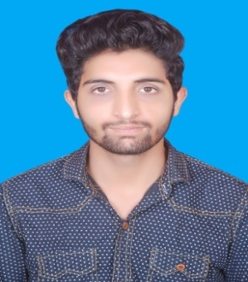
International City, Dubai
Sheher

Petroleum & Gas Engineer
+971501685421
- sheher.343383@2freemail.com

CAREER OBJECTIVE
To secure a good position in the field of Petroleum and Gas Engineering that will challenge and strengthen my Education and professional skills.

ACADEMICS
- B.Sc. Petroleum Engineering University of Engineering & Technology, Lahore 68.75%
2012-2016
- Intermediate (FS.C) BISE MULTAN 87.45%
2010-2012
- Matriculation BISE MULTAN 92.95%
2008-2010

FINAL YEAR PROJECT
- Designing an Optimized Field Development Plan for Tight gas Reservoirs
Set an optimized plan and developed a field for tight gas reservoir, Major focus was on Well spacing and fracturing off rock.

TECHNICAL SKILLS
- Mini project on Well interpretation of Naturally Fractured Reservoirs
- Attended one day workshop at Well Testing software ECRIN(SAPHIR)
- Introduction to PETREL conducted by Schlumberger Information Solution (SIS).
- Visited OGDCL yard and Field tour to Chak Naurang.

SOFTWARE SKILLS
- MS Word
- MS Excel
- MS PowerPoint

ACHIEVEMENTS AND SOCIAL WORK
- Member of Society of Petroleum Engineers
- Received certificates form Punjab Youth Festival
- Active Member at UET Science society, Pakistan Students Welfare Organization,Lahore
- Won competition of 100 & 400 meter race in school at district level
INTERESTS
- Cricket
- Movies
- Volunteering
- Travelling

PERSONAL INFORMATION
- Nationality : Pakistani
- Marital Status: Single
- Visa Status: Long Term Tourist
- DOB : 07-02-1994
- Religion: Islam

Referencewill be provided upon demand.

