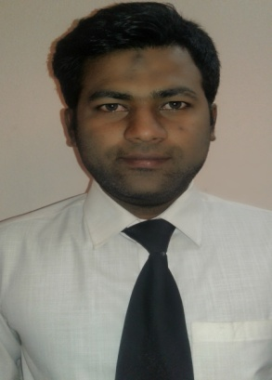
SAFDAR.
C/o-Mob: - +971504973598
Safdar.343393@2freemail.com

Career Objective:

To work and grow with an organization which gives me opportunity to utilize my interpersonal skill to fulfillment of the organization’s objective.

Work Experience:

- Worked as Account Assistant in AGARWAL& SON’s TEXTILES from April 2014 to Dec 2016.
- Worked as foreign exchange telex transfer in REDHA AL ANSARI EXCHANGE EST from May 2011 to May 19 2013.
- Worked as an accountant in COLLEGE OF HOME SCIENCE from 2008-2010.

Education :

- Bachelors of Commerce from Rajasthan University (2005-2008).
- Intermediate with C.E.C from Dharmavant Junior College, Hyderabad.
- S.S.C from St. John public school, Hyderabad.

Major Job Responsibilities:

- Handling the accounts job in the Branch.
- Perform financial transactions (cash, transfers, foreign, exchange) timely and accurately.
- Being vigilant and alert on possible fraud.
- Inward and outward transactions processing.
- Experience in detection and preventing of anti-money laundering
- Processing the EWPS and dispatch salary to the employees
- Eliminate risk of cash differences by following diligently the process set & ensuring accurate delivery of cash to customer.
- Coordination with Head Office for branch related task.
- Monitoring the inward and outward transfers and prepare reports for the Head Office.
- Preparation of sales reports.

Training and Seminars attended:

- Training conducted by National Bond Corporation in issuing of ‘National Bonds’.
- Training conducted by National Bank of Abu Dhabi related to E-government debit card.
- Internal training in (AML) Anti Money Laundering
- Training in Western union money transfer.
- Training in EWPS system for the salary payment of employees.

Computer Skills:

- MS-Office (Word, Excel, Power Point).
- Accounting Packages Tally,Focus,& Wings.
- Operating system MS-DOS, windows 2000.

Personal Profile:

Date of Birth : 02/04/1982.
Sex : Male.
Marital Status : married
Nationality : INDIAN.
Hobbies : Browsing.
Languages Known : English, Hindi, Urdu, and Telugu.
Visa Status : Visit Visa

