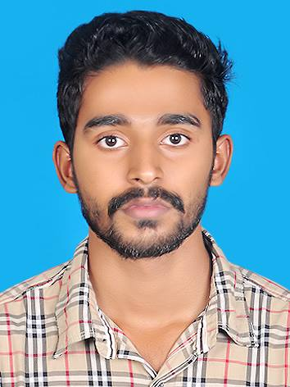 | SHOUHEED  Email: shoufeed.343395@2freemail.com  C/o-Phone: +971505891826

CAREER ASPIRATION:

As a graduate in Commerce and Accounting, I am ambitious of building a career in Accounting and Finance Management and aiming to attain positions in dynamically growing business organisations those offer professional growth and where I can apply my skills and knowledge essential for managing key areas of an organisation as a career beginner.

POSITIONS SOUGHT:

I would seek any of the following job positions, but not limited to, as a beginning in the gradual development of my career:
- Accountant, Accounting Assistant.
- Financial analysis and information management related jobs.
- Records Management and Document Control jobs.
- Administrative and Clerical positions.

ACADEMIC QUALIFICATIONS:

BBA. – Bachelor of Business Administration - 2015
Khidmath College - Calicut University, Malappuram, Kerala, India

Senior Secondary School Examination (Kerala Syllabus - Kerala) - 2011
Commerce and computer application – Schooling at Kerala

Secondary School Examination (Kerala Syllabus - Kerala) – 2009
Schooling at Kerala

PROFESSIONAL TRAININGS:

Diploma in Computerised Professional Accounting – Jawaharlal Nehru Education & Charitable Foundation, Malappuram
Six months work oriented business accounting program that provides hand-on training in:
- Manual book keeping and accounting using ledger books.
- Computerised accounting using Tally and Peachtree applications.
- Financial analysis and reporting using Microsoft Excel and other Office applications

TECHNICAL SKILLS:

Accounting applications:
- Tally and Peachtree – Setup accounts, data entry, accounts analysis, and prepare balance statements and reporting

Office automation applications:
- Microsoft Office software – MS Excel, MS Word, MS PowerPoint, MS Outlook, etc.

Touch-typing:
- English touch-typing at a pace of 30 characters / min.

Languages:
- English, Hindi, Malayalam

WORK EXPERIENCE:

Now currently working as sales attendant in ADNOC dist. Abudhabi , UAE
(Employment number : 22138 )
Responsibilities handled:
- Filling fuel
- Costumer satisfaction
- Cash handling and dealings

PERSONAL DETAILS
Date of birth: 23-04-1994
Nationality: Indian
Marital status: Single

