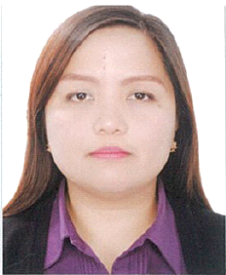 Renilda
C/o-Mobile +971505891826
E-mail renilda@2freemail.com

Personal Data | Date of Birth : November 10, 1982  Civil Status : Married  Citizenship: Filipino  Religion: Christian  Visa Status: Visit Visa
Education  Tertiary Level  Secondary Level  Primary Level | De La Salle University – Dasmariñas  Dasmariñas City, Cavite, Philippines  1999 – 2003  Bachelor of Science in Business Administration  Major in Marketing Management  Cavite School Of St. Mark  Bacoor, Cavite, Philippines  1995 - 1999  Cavite School Of St. Mark  Bacoor, Cavite, Philippines  1988 - 1995
Work experience | Data Encoder / Timekeeper  Meralco Industrial Engineering Services Corporation (MIESCOR)  Ortigas Center, Meralco Avenue, Pasig, City, Philippines  February 2009 – January 2017  Inventory Clerk  Lufthansa Technik Philippines  Macro Asia Villamor Airbase Pasay, City, Philippines  November 2007 – August 2008  Office Staff  HRD S. Pte. Ltd. – Epza Rosario, Cavite, Philippines  July 2006 – October 2006  Sales Representative  Novacell – SM Bacoor Branch – Bacoor, Cavite, Philippines  November 2005 – December 2005
 | I Hereby Certify that the above information is true and correct to the best of my knowledge and belief.

