Musharraf  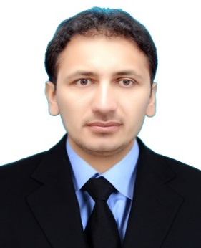  E-mail  Musharraf.343413@2freemail.com  Contact  C/o-Mobile: +971502360357  Address  QATAR, Doha  Personal Data  D.O.B. : 10-Apr-1986  Sex : Male  Status : Married  Nationality : Pakistani  Date of issue: 19-May-2015  Date of expiry:17-May-2020  Languages Known  English (Read, Write & Speak).  Urdu (Read, Write & Speak).  Pashto (Read, Write & Speak). | 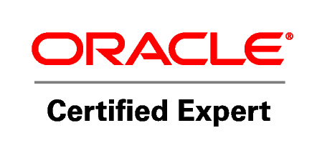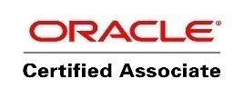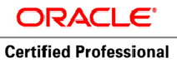  Profile  An IT Professional efficient, analytical, well-organized, reliable,trustworthy, meticulous and positive thinking individual with effective presentation and communication skills with ability to prioritize and plan forward. I am also energetic and friendly person who can communicate well. Responsible for the technical and administration aspects of the companies Oracle and SQL Database infrastructure.  Skills and Areas of Expertise  - Database Administrator.  - Complex Queries.  - IT Maintenance.  - IT Technician.  - Hotel Management (IT).  - Linux/Networking.  - Office Administration.  - Data analysis.  - Desktop Support Application.  - Diagnosing hardware & software faults.  - Deadline oriented.  - Quick learn company software/Interface.  - Teaching.  - Excellent problem-solving skills.  - Honest, Hard and smart Worker.  - Adapt to any work atmosphere.  Education  - M.SC Computer Science: 2011- 2013(Institute of Management  Sciences (ims) University) Hayatabad Peshawar Pakistan.  - BSC Computer science: 2011, Peshawar University Pakistan.  - Major Courses: Data Communication, Database, Data structure,  Calculus And Operating system.  Computer Courses  - Oracle Certified Expert (OCE) / Oracle Certified Associated (OCA) & Oracle Certified Professional (OCP)from TECHNO-ED Islamabad.  - Red Hat Linux Operating system from TECHNO-ED Islamabad.  - MCSE (Microsoft Certified System Engineering) from Corvit Peshawar.  - CCNA from Corvit Peshawar.  - Computer Hardware/Software.  - Proficient in MS Office, Windows, Internet & Email.

Certifications

- Oracle Database 10g.
  - Oracle Certified Expert (OCE).
  - Oracle Certified Associate (OCA).
  - Oracle Certified Professional (OCP).

Experience

- In Database Administrator, Jan/2014 – Dec/2014, One Year Experience
InTECNO-ED Islamabad Pakistan.
- Database Backup and Recovery, Maintain Data and so on.
- Creating backup copies of data.
- Oracle RMAN.
- User Profile and auditing.
- Troubleshooting.

- Structure Query Language (SQL),
- Data Retrieval Language (DRL).
- Data Manipulation Language (DML).
- Data Definition Language (DDL).
- Data Control Language (DCL).

- Taking ownership of data related problems.
- Database Installation and Configuration.
- Developing and building systems for end users.
- In-depth knowledge of Microsoft Windows client operating systems, XP, Windows7/Windows 8,So on and Linux Operating system.
- In Networking, Six Months Experience in Rahman Medical Institute (RMI).
- Active Directory Installation.
- Convert FAT to NTFS file system without formatting
- File and folder permissions,quota and so on.
- Router Configuration.
- Cabling/Wiring.
- Troubleshooting.

- In Red Hat Linux In 2014, one year Experience In TECHNO-ED Islamabad Pakistan.
- In Teaching, Two Years’ Experience in Mathematics Up to 8th class.
- In Hotel, InJAN-2015Up to JULY-2016,(0ne and Half Year Experience)By 72 Hues
Five Star Hotel in Sharjah UAE.
- As an IT Assistant.
- Wi-Fi Troubleshooting.
- Projector Setup, Sound/Mac/Mixer and Speaker.
- Projector Troubleshooting.
- Windows Upgrade.
- Avaya Installation and configuration/Telephone Troubleshooting.
- Key Door Lock Troubleshooting use a device.
- HSMX, It for Wi-Fi password access to use guests.

- Membership Card Creation.
- Printer Troubleshooting.
- Fire Alarm Troubleshooting.
- Master Card creation.

- In World Health Organization (WHO), Six Months Experience (From August to December 2016)
As an Additional Monitor.
- Checking Area Supervisor.
- Checking CHW and Team.
- Checking logbook, vaccine and so on.

Project

- Local Area Network (LAN) Messenger for Rahman Medical Institute Pakistan.
- Communication more than one system.
- LAN Messenger, No need of the internet, without internet communication.
- Chat, files, Pictures sending through the LAN Messenger.
- Fast and secure Send and receive data.
- Friendly user Desktop Application.
- Easy Understand.

Applied for
- Database Administrator.
- Structure Query Language (SQL).
- Red Hat Linux Operating System.
- Networking.
- IT Officer (MS Office).
- IT Assistant.
- IT Technician.
- Desktop Support Application.

