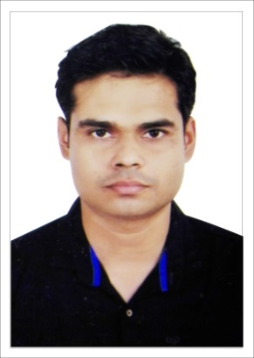
Sanoop
C/o-Mobile: +971502360357
Email: sanoop.343430@2freemail.com

Objective:
To obtain a challenging and responsible position in the Information systems field, with an organization committed to staying on leading edge of technology.

Professional Experience 1:
Company: KOTTOOR INTERNATIONAL LLC (Dubai)
Job Profile: Network Engineer /Systems Engineer /IT Infrastructure Engineer
(Nov 2013 to till date)
- Installation and configuration of routers (Cisco, Sonicwall, Cyberom) and switches.
- Configuring and trouble shooting of VPN Connections between site to site and site to client.
- Trouble shooting network LAN and WAN effectively.
- Regular checkup of server backup.
- Installation, configuration of NAS device (Buffalo and Iomega). Scheduling backup for servers.
- Installation of windows servers 2008, 2012. Creation of domain and managing active directory users with secured permissions according to the client requirement.
- Mail server management. User management and outlook client management.
- Windows system administration and Linux system administration. Installation of software and trouble shooting of systems.
- Office network setup with installation of Router,Pabx, CCTV and Security Devices.

- Configuration of CCTV Systems IP Camera, Dome Camera.
- Installation of DVR, NVR, Initialization of Hard Drives. Trouble shooting of remote connection systems.
- Installation and Configuration of Security Systems Access controls, Time and attendance machines, Door phone systems.
- System Administration, employee support, network troubleshooting
- Day to day network monitoring.
- DNS/ Active Directory Installation & Configuration.
- Creation of Users, Groups, Organizational Units.
- DHCP Installation & Configuration & DHCP Relay Agent.
- Remote Installation Services (RIS).
- Routing and Remote Access (Dial-up, VPN).
- Network Configuration.
- Connectivity Between Linux to Windows (Telnet, Hyper Telnet & Terminal Services)
- FTP Configuration.
- Protocols used: TCP/IP, POP3, IMAP, Telnet, HTTPS, DNS, DHCP.
- ITIL V3 Processes.

Professional Trainings:
- Trained for CCNA from Network Academy Calicut,Kerala
- Trained for MCITP from Network Academy Calicut,Kerala
- Planning to do Storage Training and Certification in RHCE and CCNA.
- Trained for RHCE.

Academic qualification:
Qualification | Institution | University/Board | Year of passing | % Scored
BCA | MGKVP University | MGKVP University | 2012 | 66%
B.sc Mathematics | University of Calicut | University of Calicut |  | -
+2 Science | GHSS Veliyancode | Kerala HSE | 2007 | 45%
SSLC | GHSS Veliyancode | Kerala State Educational Board | 2004 | 45%

Strengths:
- Ability to work effectively in a team environment as well as independently.
- Adaptability
- Self-Motivated
- Quick learner
- Patience

Personal Details:
Languages Known : English, Hindi and Malayalam
Nationality : Indian
Hobbies : Playing Sudoku,Surfing Internet

Declaration:
I hereby declare that all the information above is true and to the best of my knowledge and if given an opportunity, will work to the best of my abilities and prove worth of my selection.

