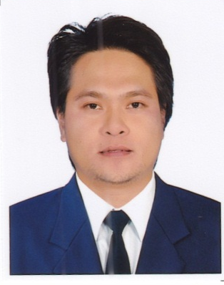
JOEMAR
C/o-Contact No. +971503718643
E-mail: joemar.343433@2freemail.com

CAREER OBJECTIVES:
To obtain a position where I can utilize my talent and skill and further enhance them to contribute to my development as a person and to be able to be part of a team.

SUMMARY OF QUALIFICATIONS:
Having more than five years in the field of customer relations, providing a productive output that help to attain the company objective, I can offer a job that guaranteed less supervision, can work under pressure, good command in English written and spoken, professionalism and good relationship with colleagues and customers.
WORK EXPERIENCES:

Production Operator —APCP INC., New Taipei, Taiwan(March 2010 – March 2016)

- Follow safety procedures and company policies for machine operation.
- Operate machine safely and effectively for production processing.
- Setup the production machine and supplies before executing the job orders.
- Ensure that machineis maintained in good and safe working condition.
- Inspect machine to identify any replacements, malfunctions and repairs.
- Perform regular equipment maintenance to ensure production capacity and quality.
- Identify and report unsafe operations to Supervisor immediately.
- Maintain the work area clean, safe and organized.

Food / Room Attendant— Lourdes Suite @ Hotel Tiara, Makati City, Philippines (November 2008 – December 2009)

- Smile and greet the customers.
- Take food and beverage order and serve.
- Salesmanship, Ensure safety, hygiene and sanitation.
- Present a check or bill and receive payment
- Checks and secures the rooms.
- Replenish amenities according to the operational standards.
- Ensure security of guest rooms and privacy of guests
- Responsible for the cleanliness and maintenance of his work area.
- Attends to guest calls, guest requests /guest complaints in the area assigned to him.

Gym Fitness Instructors —Slim and Shape Fitness Center, Caloocan, Phillippines(April 2008 – October 2008)
- Demonstrate the correct way to use exercise equipment
- Monitor the misuse of equipment
- Ensure the gym is clean and free of health and safety hazards
- Deliver exercise classes and workshops
- Develop personal exercise and diet plan
Production Operator —CDO Foodsphere. Valenzuela City, Phillippines
(April 2007 – February 2008)

- Follow safety procedures and company policies for machine operation.
- Operate machine safely and effectively for production processing.
- Setup the production machine and supplies before executing the job orders.
- Ensure that machine is maintained in good and safe working condition.
- Identify and report unsafe operations to Supervisor immediately.
- Maintain the work area clean, safe and organized

Sales Executive— RRJ Company @ Robinson Ermita, Manila, Philippines
(May 2006 – February 2007)

- Smile and greet the customers.
- Be involved in stock control and management.
- Stocking shelves with merchandise.
- Answering queries from customers.
- Reporting discrepancies and problems to the supervisor.
- Give advice and guidance on product selection to customers.
- Keeping the store clean and tidy.
- Responsible dealing with customer complaints.

EDUCATIONAL BACKGROUND:
B.S. In Business Administration Major in Management
University of Caloocan City, Philippines (Year 2004 – 2006 )

SEMINAR AND TRAINING:

The Power of Service in Excellence training and Workshop
in Hotel and Food & beverages Operations (May 18 -22, 2009 )
Interlink Manpower Development & General Services In

Computer Education & Livelihood Project (April 2-15 2008)
Technology Resource Center Philippines

Acting Training Program (April 19-20 2007)
Actor’s Studio East - Cubao, Quezon City, Phillipines

PERSONAL INFORMATION:

Sex : Male
Height : 5’8”
Status : Married
Religion : Roman Catholic
Visa Status : Visit VIsa

