**Curriculum Vitae**

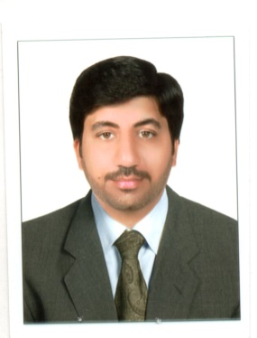

*Sayed*

Contact:

C/o-Mob UAE: +971 502360357

E-mail: [sayed.343458@2freemail.com](mailto:sayed.343458@2freemail.com)

**Career Objective**

I am searching a job where I can exploit my potentials and have great keen and zeal to serve anywhere with a relevant job to get dines and attires for my family in this dearth epoch.

**Academic Qualification:**

* *BS Computer Science* Equivalent to Masters, University of Peshawar, Pakistan.

2008 - 2011.

* *HSSC (Pre Engineering)*Islamia College Peshawar. *2005-2007.*
* *SSC (Science)* Islamia Public School, Parachinar.*2005.*

**Skills:**

* Networking (MCSE, MCITP, CCNA).
* Data Bases (Oracle 10g Development and Administration).
* C, C++, JAVA.
* Operating System (Windows XP, Windows 7and Windows 8).

**Professional Experience:**

* Worked for USAID as a Coordinator one year.
* Worked as System Administrator at IT Alrounders Peshawar (2011-2013).
* Worked as a Teacher at Bu Ali Sina College, Peshawar (2008-2011).
* Worked for welfare society (Haideri Blood Donation Centre).

Working as a Customer Services Representative in SALIK department, Roads and Transport Authority (RTA) Government of Dubai from July 2014 onwards…



**Personal Information:**

|  |  |
| --- | --- |
| Date of Birth :  Passport No :  Present address :  Marital Status : | 20th January, 1990.  US6899691.  Al Baraha Deira Dubai.  Married |

**Languages known:**

Language Read Write Speak.

English Excellent Excellent Excellent.

Urdu Excellent Excellent Excellent.

Hindi Excellent Excellent Excellent.

Pashto Excellent Excellent Excellent.