CURRICULUM VITAE

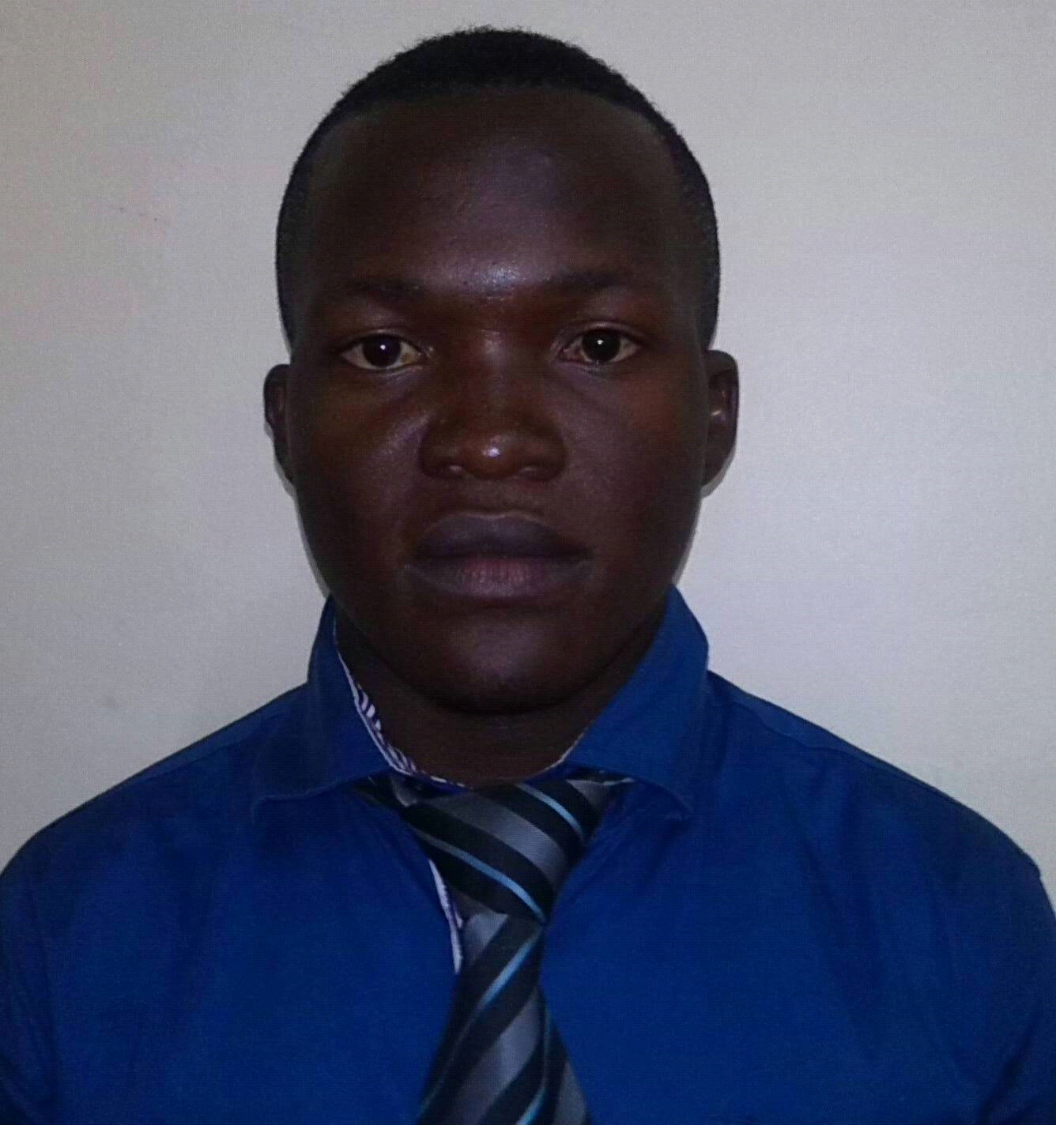
NAME: JOHN
GENDER: MALE
NATIONALITY: UGANDAN
MARITAL STATUS: SINGLE
EMAIL ADDRESS: john.343460@2freemail.com
C/o-CONTACT: +971505891826
VISA STATUS: EMPLOYMENT
LANGUAGE: ENGLISH
s
________________________________________________________________________

CAREER OBJECTIVE

Joining an ambitious company for further career and personal skills development hence, achieving the goals and objectives of the company and at the same time meet diverse people with different backgrounds who will enhance my learning and sharing information for the growth and development of the company.

PROFILE

- I am a professional security service personnel with 1 year UAE – Dubai experience and 2 years back home experience
on ground in customer service security, Hotels, mobile security and supermarket security guard.

- I am an excellent sales man with 2 years experience in a telecomunication company.
- I am very good at teamwork and very willing to learn the new things that come my way.
- I am a result Oriented, detail-oriented, disciplined and resourceful person with exceptional skills, very flexible and adaptable to new working environments combined together, gives me a foundation for an excellent team player.

Responsibilities;
• Both mobile and static day and night surveillance operations
• Boom gate inspections of vehicles and personnel
• Monitor the integrity of property boundaries
• Contact operations center and direct personnel in the event of an emergency
• Monitor CCTV
• During my sales experience I was able to identify potential customers and created sales.
• Providing outstanding customer services and satisfaction.
• Updating customers with our ongoing promotions.
• Ensuring that I meet my day to day target.

Work Experience

Security Guard- PREMIERSHIELD SECURITY (LLC) - DUBAI, from Dec 2015 up to now

Security Officer – Securex Security Guards Uganda, Jan 2012 – Feb 2014;

Novotel Hotel - Albasha, Lulu hypermarket – Al qusais
and Geant supermarket - Arabian ranches

Sales Representative - WARID TELECOM (U)

- Directing, and doing security checks on visitors to the Hotels and Supermarkets.
- Guarding apartments as assigned by my Supervisors.
- Giving security services to supermarket customers as assigned by my supervisors.
- Communicating to the head office in cases of emergency.
- Ensuring that the handover is done perfectly.
- Making attendance reports as requested by my supervisors.

Personal skills
- Communication
- Judgment and decision making
- Fire safety
- Conflict resolution
Computer Skills
- Microsoft office
- Web Technology (Internet and e-mail)

Personal interests
Fitness, swimming and marketing

EDUCATION BACKGROUND
Kampala Secondary School
Uganda Advanced Certificate of Education (U.A.C.E)

References

NB:
I will provide them upon your Request.

