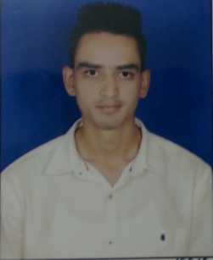

RAMEEZULLA
RAMEEZULLA.343489@2freemail.com

RESUME for Customer Service Officer Page 1-2

Summary:
    - M.B.A (Finance)
    - Certified in Tally 9.0 ERP
    - Knowledge of SCM Management
    - 1.6 year experience as Customer Service Officer
___________________________________________________________________________________

COMPETENCIES

SOFTSKILLS
Tally 9.1 and MS skills (Excel & Word)

WORK EXPERIENCE

Customer Service officer –Hinduja Global Solutions PVT LTD.Mysore,INDIA July 2015 –Till Dec 2016

CURRENT JOB PROFILE – as Customer Service Officer
- Highly skilled in development, maintenance and retention of customer relationships.
- In depth knowledge of providing excellent customer services in the area of wide business sectors in order to meet the expectations of customers and patrons.
- Hands on experience in resolving queries within timescale.
- Maintain databases of daily job reports.
- Encourage feedback on services provided.
- Deliver accurate, quick and resourceful customer service.
- Maintain the delivery at right time to customer by tracking the vehicle.
- Possess right time quality workmanship & right time job delivery
- Ensured workflow efficiencies, customer service excellence and quality assurance
- Provide customers with regular reports and feedbacks on their services.
- Offered feedback on future products development, features and functions.
- Answered customer questions regarding the technical capabilities of product and services
- Exercise a mature, diplomatic approach to resolving problematic issues, put customers at ease.
- Drafting the required paper work on data base management through ERP.
- Planning Logistics in cost and time effective manner.

Page 2-2

Professional Qualification:

- B.com in commerce from D.Banumaiah’s college Mysore, india –June 2013 ( 50.56%).
- M.B.A (Finance) from Satellite Post Graduate Centre mysore, india-June 2015 (59.30%).

Computer Literacy
- Working knowledge of Tally 9.0 ERP,
- Proficient in MS Office Suite, Windows 98, XP, 7.

CERTIFICATIONS

CERTIFIED as MBA in Finance from Satellite Post Graduate Centre, Mysore University.

- CERTIFIED as B.com in commerce from D.Banumaiah’s college mysore University.

