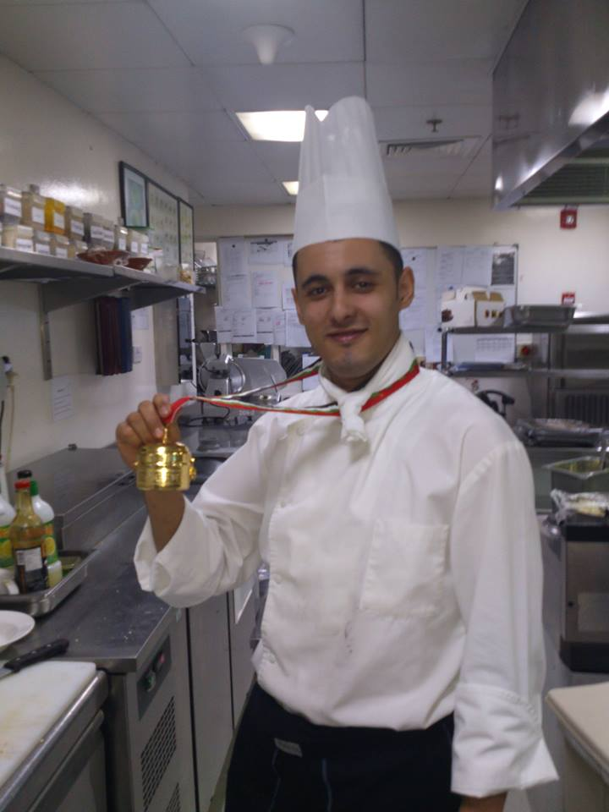 Kinan

Personal Information:

C/o-Mobile: +971503718643
E-mail: kinan.343501@2freemail.com

Career Objectives:

Graduate in Hospitality management with a lot of enthusiasm, passion, academic knowledge and field experience seeking a chance to continue a successful career with a reputable hotel chain or hospitality industry that offers opportunity for more field experience, advancement and rewarding career.

PROFESSIONAL HIGHLIGHTS
• 11years’ experience in managing kitchen operations and supervising staff
• Demonstrated ability to prepare hygienic and delicious food following prescribed menu, recipes and techniques
• Well versed in assigning responsibilities to culinary staff
• Known for setting deadlines ensuring the timely completion of work
• Able to create and maintain excellent rapport with the patrons and co-workers
• Competent at preparing and organizing banquet as well as restaurant meals

Work Experience Detail:

* Mövenpick Hotel Jumeirah Lakes Towers
Position Junior Sous Chef
Work period from 10/03/2016 till date

*media rotana hotel
Position chef De partie
Work period January 01/03/2015 until 01/03/2016

* Diera Coral Hotel Dubai
Position chef De partie
Work Period January 01/03/2013 until 01/01/2015

* Torino Restaurant
Position Chef De Partie
Work Period From 25/02/2012 until 30/12/2012
* Beach Rotana Hotel
Position Commis I Work Period From 13/11/2009 until 25/02/2012
*Shaheen Hotel And Tower
Position Commis I
Work Period 2007 _ 2009

*Al Qaisar Hotel
Position Commis II Work Period 2006 _ 2007

Personal Data:

Date of Birth Oct 10th 1989
Nationality Syrian
Marital Status Single

Education:

*High School of Tourism and Hotels.
*Cerfificate of Food Hygiene(RMK)
*HABC level (2 )Award in Food Safety in Catering (QCF)

Languages:

1- Arabic: Fluent
2- English: Good

Special Skills & Abilities:

*Good communication / organizational and management skills
*High level of personal hygiene
*Ability to resolve conflicts efficiently
*Attention to detail – Ability to quickly discover and resolve problems
*Languages : Fluent in English, Arabic & good speaking of Russian

I hereby declare that the above mentioned information is true and correct to the best of my knowledge and belief

