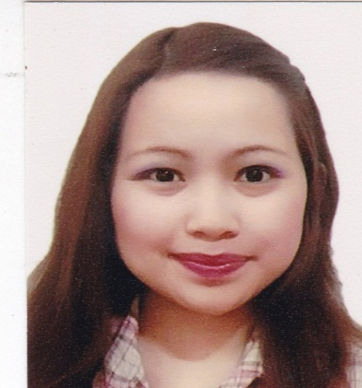
Maria
C/o- +971505891826
maria.343502@2freemail.com

OBJECTIVE:

To obtain a full time position in a multinational which offers a professional working and enables me to grow while meeting the corporation’s goal.

SKILLS:
Computer: Familiarity with Microsoft word, excel and powerpoint
Languages: Tagalog (native), English (fluent)
Enthusiastic, quick to learn with good interpersonal and organizational skills, Have a high sense of responsibility, good oral and written communication skills, creativity, marketing skills, and interpersonal skills.

EDUCATION:

VIRGEN MILAGROSA UNIVERSITY FOUNDATION
San Carlos City Pangasinan, Philippines
Bachelor of Science in BUSINESS ADMINISTRATIONmajor in MARKETING MANAGEMENT.
June 2009-April 2013

Honors and Awards:
Dean’s List
VMUF Drum and Bugle Corps scholar June 2009-April 2013

Activities:
VMUF Drum and Bugle Corps President June 2012-June 2013

Coordinates with the school president regarding DBC engagements
Organized band events including regular band get together and special occasions such as Christmas.
Attends seminars and meetings regarding DBC competition and incoming engagements.

WORK EXPERIENCE:
Company: Optis Philippines Inc.
Gateway, Manggahan General Trias, Cavite, 2428 Philippines
Administration Officer-Human Resources (RECRUITMENT)

Company: Emirates Fast food-McDonalds UAE
Al WaselCoop (54069)
STORE ACTIVITY REPRESENTATIVE
January 2014 – January 2017

SEMINARS ATTENDED:

- Entrepreneurship Seminar
October 4, 2011
VMUFSan Carlos City Pangasinan, Philippines
- Building Wealth from Stock
March 2, 2012
VMUF San carlos City Pangasinan, Philippines
- Self Employment Workshop
March 21, 2012
VMUF San Carlos City Pangasinan, Philippines
- Go NegosyoYoug Entrepreneurship
August 31, 2012
University Of PangasinanDagupanPangasinan, Philippines
- Job Application Lecture 2013
March 02, 2013
VMUF San Carlos City Pangasinan, Philippines
- Natasha Beauty make up personality Development
March 22, 2012
VMUF San Carlos City Pangasinan, Philippines

PERSONAL INFORMATION:

Date of Birth : September 2, 1992
Place of Birth : San CarlosCity,Pangasinan
Age : 24 y/o
Height : 5’1
Weight : 50 kilos
Civil Status : Single
Citizenship : Filipino
Language : English,Tagalog

I HEREBY certify that above information are true and correct to the best of my knowledge and belief.

