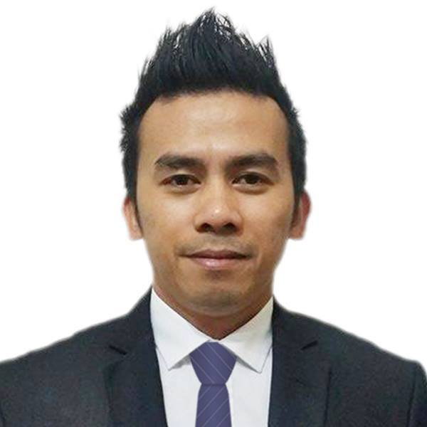
CAREER OBJECTIVE:

ADRIAN
ADRIAN.343510@2freemail.com

Position can Apply for:

Salesman/Sales Associate
Merchandizer
Office Assistant
House Keeping Attendant
Room Attendant
Bell Boy
Waiter
Sales Promoter
To obtain a position that suits on my qualification in an organization that will provide me with the opportunity to offer exception result across my fields. Extremely focused on elevating company standards and clients expectation. I am hard working person, innovative and can work minimum supervision. I believe that I can handle the task required for the position I am applying for.
SUMMARY OF EXPERIENCE AND QUALIFICATION
MESSENGER / OFFICE ASSISTANT
(December 17, 2014 –December 18, 2016)
ELITE MEDICAL CLINIC

Duties and Responsibilities
        - Cleaning dental room, reception area.
        - Assisting clients / patients to doctor’s room.
        - Serving coffee and tea to clients/patients.
        - Maintaining cleanliness to the entire villa center or whole area.
        - Fabricating or making plastic and acrylic retainer night guard.

SALESMAN/SALES ASSOCIATE
(April. 2013 - Sept. 2014)

BENCH COMPANY AT DEPARTMENT STORE ROBINSONS MALL LIPA CITY is a Sales and Retail Services/Sales/Clothing/Shoes and garments.

ROBINSONS MALL LIPA CITY
SALES ASSOCIATE (Sept. 2012 - March 2013)
DICKIES USA, SM MALL LIPA CITY is a Sales and Retail Services/Sales/Clothings/Shoes and garments.

Duties and Responsibilities
        - Greet customers in a timely fashion while quickly determining their needs.
        - Helps customers select products that best fit their personal needs.
        - Merchandise and product replenishment to a guarantee size availability and promote customer satisfaction .
        - Complete all cleaning, stocking and organizing task in assigned sales area.
        - Prioritize helping customers over completing other routine task in the store.
        - Contributes to team success by exceeding team sales goals by 100%.
        - Build and maintain effective relationships with peers and upper management.

SILK SCREEN PRINTER
(Jun 2011 - Aug 2012)
UBN Graffitti is a printing/Artworks/Tarpaulin Printing/ Signage and T-shirt Printing.

Duties and Responsibilities
- Make silkscreen canvas and printing on t-shirts, garments etc.
- Handle and mixing textile paint.
- Assist clients.

PROPERTY SPECIALIST/REAL ESTATE AGENT
Sales Department (Jun 2007 - Jun 2011)

Avida Land Corporation is a Property/Investment/ Real Estate
Lipa City, Philippines

Duties and Responsibilities
- Sales presentation to clients not limited to follow ups, closing of transactions and processing of documents concerning on sales.
- Marketing exhibits, booth and site manning, fleering, saturation.
- Undergo Salesmanship workshop, PEP/ I- BEST & SAP training.

ROOM ATTENDANT (Sept 2005 - Jan 2010)
Anfa Royal Hotel
Lipa City Batangas, Philippines

Duties and Responsibilities
- Stocks and sort supplies. Vacuum,clean,dust and polish guest rooms.
- Make beds, change sheets,remove and replace used towels and toiletries.
- Deliver and retrieve items on loan to guests e.g. iron and ironing boards.
- Ensure security of guest rooms and privacy of guests.
- Perform rotation cleaning duties (e.g. steam cleancarpets) as required.

HOUSE KEEPING/ROOM ATTENDANT (2001 - 2003)
Austers Plaza Hotel
Lipa City Batangas,OOPhilippines

KITCHEN CREW/ WAITER (1997 - 1998)
Wanam Food Palace
Bauan Batangas City, Philippines

SUMMARY OF EDUCATION:

June 1999 - November 1999 HOTEL AND RESTAURANT MANAGEMENT
(Undergraduate)
Education Field: Food and Beverage Preparation/
Service Management
Lyceum of the Philippines, Batangas City, Philipines

