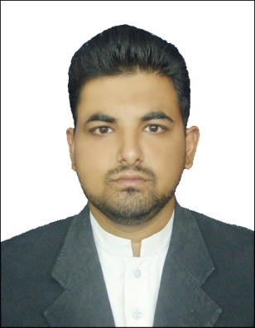
Nasir
Rawalpindi Pakistan.
Email: nasir.343528@2freemail.com

Career Objective:

To succeed in an environment of growth and excellence and earn a job which provides me job Satisfaction and self-development and help me achieve personal as well as organization goals.

Personal Information:

Nationality: Pakistani.
Date of Birth: 03, September, 1988.
Gender: Male.
Marital Status: Married.
Religion: Islam.

Academic Information:

- Matric (Jan-2005 - June-2007)
Subject: Science.
Division: 2nd
Board: Federal Board.

- Intermediate (Feb-2007 – Oct2009)
Subject: Computer, Math, State.
Division: 2nd
Board: Federal Board.

- BSCS/IT Honors (September-2012 –September-2016)
(Preston University Islamabad)
1st Semester GPA: 4.0
2nd Semester GPA: 3.6
Summer-I Semester GPA: 4.0
3rd Semester GPA: 4.0
4thSemester GPA: 3.4
Summer-II Semester GPA: 4.0
5th Semester GPA: 3.7
6th Semester GPA: 4.0
Summer-III GPA: Internship (Askari Bank)
7th Semester GPA: 3.6
8th Semester GPA: 3.2
Summer IV Semester GPA: 3.3

Professional Qualification:

1. Auto Cad (Aug-2009 - Oct-2009)
Institute: Construction Technology Training Institute Islamabad.
Remarks: Grade A

2. Civil Draftsman (June-2009 – July-2009)
Institute: Alnoor Academy
Remarks: Grade A

Job Experience Detail:

1. Store Keeper Auto parts & Accessories (Jan-2010 – October-2012)

Organization: Sigma Motors Ltd (Land Rover).
Tasks: Mailing and Updating Online Orders, Handling Inventory Stock (Inventory Sheet) and updating to Manager, Updating Expenses in Excel Sheets, Handling Data Base and Backup of the Previous Records etc.
Location: Islamabad (Pakistan).

2. General Banking and Operations (June-2015 – September-2015)

Organization: Askari Bank Limited
Tasks: Handling and Updating Customers Records and Accounts, Maintaining Expenses, Balance Sheets, Credit and Debit Record
Maintaining, Dealing Customer’s Locker etc.
Location: Rawalpindi (Pakistan).

- Computer Operator (Oct-2015 – November-2016)

Organization: National Maternal Newborn and Child Health (MNCH) Program
Tasks: Children Vaccinations Record, New Born Children Records, Register
Name of Children and Parents, Discharge Certificate Issuance,
CCTV monitoring etc.

Location: Lahore (Pakistan).

Computer Skills:

- Operating System (Win XP, Win Me, Win Vista, Win 2000_2012, Win 7, 8 &10).
- Microsoft Office (World, Excel, PowerPoint, Access, Outlook).
- Installation Windows and Software.
- Computer Hardware.

Languages:

1. Urdu
2. Punjabi
3. English

