KAREN
Dubai, UAE
karen.343562@2freemail.com
C/o- +971505891826
HUSBAND VISA

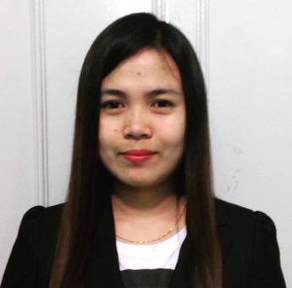
__________________________________________________________________________________
POSITION: RECEPTIONIST/SECRETARY/IMPORT/EXPORT DOCUMENTATION ASSISTANT
OBJECTIVES: Looking for a long term full time job where I can apply my extensive skills and knowledge to the position for which I am hired.
WORK EXPERIENCE:

Receptionist cum Import/Export Documentation Assistant October 2014 – Nov 2016
WELCARE SHIPPING LLC
Dubai, UAE

Job Description:
- Managing the reception area including greeting visitors and responding to telephone and in-person request for information.
- Deal with all inquiries in a professional and courteous manner, in person, on the telephone, or via e-mail
- Direct visitors by maintaining employee and department directories.
- Receiving international and local calls, and sorting daily mails/couriers.
- Performing other clerical receptionist duties such as filing, photocopying, faxing etc.
- Communicating with customers for Delivery Order charges/Storage/Handling/Free time.
- Receiving payments and issuing invoices.
- Updating Customer’s details in the company system.
- Making Import/Export declaration using online portal Dubai Trade MIRSAL 2.
- Doing E-Payment Online/E-token/Gate Pass/Bill of Entry/DP World Payment.
______________________________________________________________________________
Marketing Assistant January 2012 – July 2014
SYM MOTORS CORPORATION
Maria, Aurora
3202 Philippines

Job Description:
- Generate income for the company by selling motorcycles.
- Preparing sales report/marketing plans and strategies.
- Traveling to different local areas in the community to source, manage, and negotiate with potential customers to promote and sells motorcycles.
______________________________________________________________________________

TRAININGS: RTC (REGIONAL TRIAL COURT)-STENOGRAPHER
MUNICIPAL HEALTH CENTER - MEDICAL ASSISTANT MOUNT CARMEL COLLEGE – Office of the Vice President

PERSONAL INFORMATION
PLACE OF BIRTH: San Luis, Aurora, Philippines
NATIONALITY: Filipino
STATUS: Married
LANGUAGE: Filipino and English
SKILLS: Knowledgeable on computer, MS Office.
Dedicated, Flexible and Resourceful
VISA: HUSBAND VISA

EDUCATIONAL BACKGROUND

COLLEGE: Bachelor of Science in Office Administration
Mount Carmel College
Baler, Aurora, Philippines

I hereby certify to the correctness of the above information.

KAREN
Applicant

