RESUME
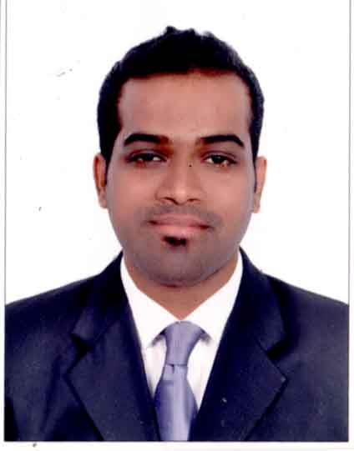
Eashan
E-mail: eashan.343578@2freemail.com
C/o- Tel: +971-505891826

Objective
To work and try to give my level best by doing my job honestly.

key skills
- Good Command over Communication both Verbal and Personal
- Quick learner and adaptive the new environment.
- Confident and Hardworking.
- Analytical Thinking.
- Problem analysis, Use of judgment and ability to solve problems efficiently.
- Tolerant and flexible to different situations
Academic Qualifications:
Degree | Year | University | Institute | Subjects | Marks
BMM  (SEM VI) | 2011 | Mumbai University | Tilak College,  Vashi | Specialization in Advertising | 64.00%
XII (HSC) | 2008 | Maharashtra State Board | S.D.V. Junior College | Commerce | 58.67%
X (SSC) | 2006 | Maharashtra State Board | St .Augustins High School., Vashi | _ | 55.20%

Computer literate:
- Good knowledge of
Adobe Photoshop (CS3 , CS5 & CS6)
Corel Draw (X5)
In-design
Illustrator
Microsoft package (MS Word, MS Excel, Power point)
Visual Fox PRO
JDA (SPACE PLANING & FLOOR PLANING)
- Typing speed: 70 to 80 wpm.

Experience:
- Currently Working at Arak International CO. LLC Dubai UAE as a Graphic Designer / Administration as of 1st December 2014 to till Date.
Description:
- Prepare order (Indenting Work ) for the orders received by sales person
- Editing the Patterns & Designs of the ready made garments sketches as per the Sales executive info.
- Designing logo and product design for the client as per there requirement.
- Package design as per client requirement (Polybag Design, Box Design, labels, Flask Design, Hang Tag)
- Maintaining the record and files of confidential data of the company.
- Preparing the letter for the customer about the payment and official work.
- Preparing the Visa for the Sales person.
- Maintain the email and Work Documents.
- Maintain the list of Buyers and Suppliers.
- Prepare the Invoice on behalf of the Suppliers
- Preparing all documents required for clearing the shipment and tracking all the shipment status.

- Worked with the Accenture Pvt. Ltd. as a Plano developer (Merchandiser) from 11 July 2013 to 30 November 2014 .
Description:
- Worked in software called JDA (Designing software for Plano Merchandiser).
- Designing the Space Planning (Shelf / Plano ) as per the client perspective.
- As per Client instruction placement of product and designing of the Plano is been done.
- As per client requirement have to merchandise the Plano i.e. Product placement and designing as per brand and category.

- Worked with Reliance BPO as a Customer Service Associate in back office Since 7th months from 25th September 2012 to 25th April 2013.
Description:
- Worked in MS Excel handled customers request of surrendering the Policy.
- Worked in the software Easy CRM & Life Asia.
- Used to pull out data from online portal and verify the customer document to surrender the insurance policy.
- Once verification is complete same has to be updated in the portal and excel sheet.

- Worked with Radiant Hospitality services as an Administrative Executive / Data Entry Operator for 1Year as of from 9th June 2011 to 30th June 2012
Description:
- Worked in MS word , Excel and power point.
- Handled team of 80 people by keeping records of their daily attendance, tracked the daily work which they do.
- Prepare MIS report on daily bases also the power point presentation for the same.
- Also used to prepare monthly attendance report for the monthly billing cycle as per client requirement.

Hobbies and Interest:
Reading, Watching Movies, Listening Music, playing football, exercise regular.

Biological Data:

Date of Birth : 13-06-1988

Sex : Male
Marital Status : Unmarried
Nationality : Indian
Religion/Caste : Hindu
Languages Known : English, Hindi, Marathi and Tulu.

Passport Details:
Date of Issue : 17 / 11 /2011
Date of Expiry : 16 / 11 / 2021
Visa Status : Employment

Declaration
I do hereby declare that what is stated above are all true to the best of my knowledge and belief.

