SMITHA  SMITHA.343611@2freemail.com | 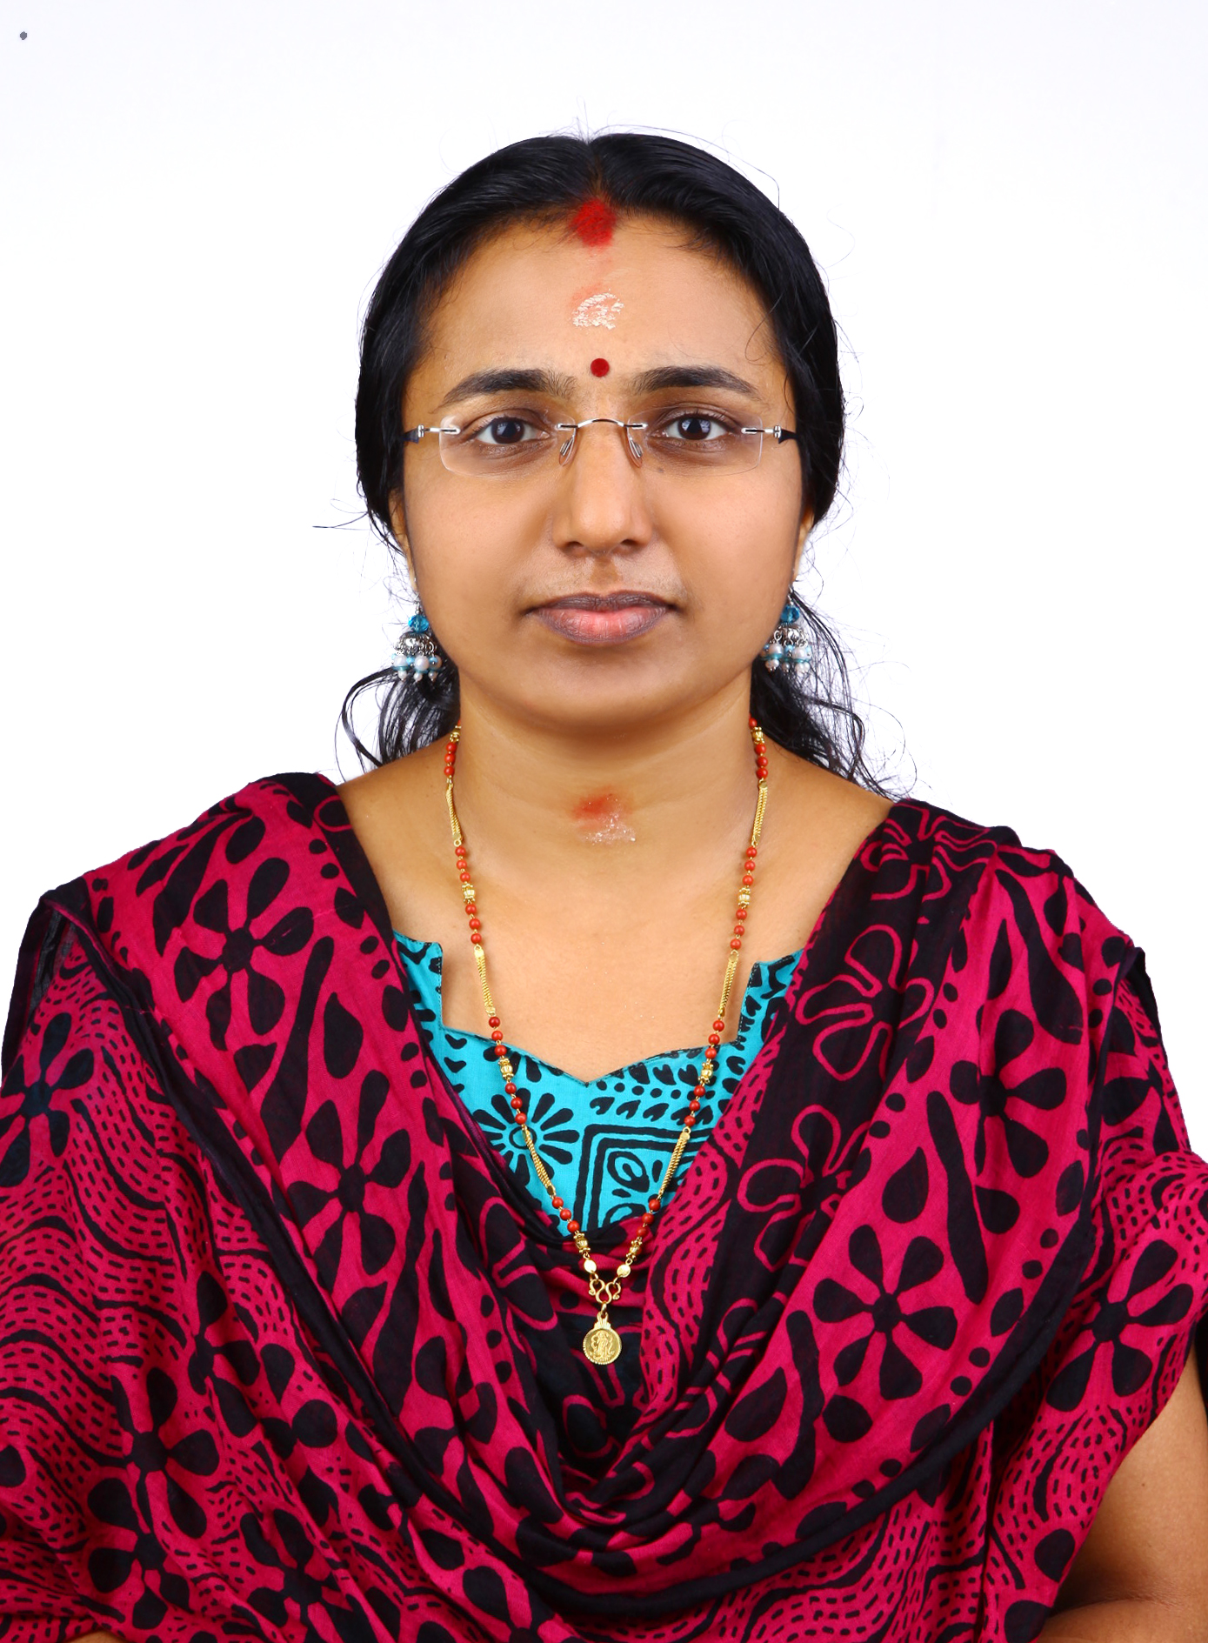
Professional Summary

Experience in accounts/payroll management with a strong background in, Organizing, Coordinating & motivation of personnel.
Skill sets

Computer Knowledge : Windows OS, MS Office package etc.
Languages known : English, Hindi, Malayalam and Tamil.

Has a valid Indian driving license.
Education Credentials

Bachelor of Commerce
University of Calicut, Kerala, India
Career Path

- November 2015- Till Date Accounts Executive & Receptionist
Al Mustwa Machinery Spare Parts L.L.C,Sharjah.
- October 2014 – October 2015 Operations Executive
Caravan Cargo L.L.C, DUBAI, UAE.

  - Review of primary sales documents & Invoicing
  - Review the documents and handle the export and import procedures
  - To advise on any impact on services caused by operational changes
  - Assist the on call customers through tele marketing.
  - Preparation of correspondences to the customers regarding the operations
  - Quantity check of the operations with supporting departments

- March 2008 – March 2010 Accounts Executive
M/s Popular Vehicles Pvt Ltd, Kozhikode, India

  - Prepare financial statements and debtors’ listings.
  - Check customers’ credit ratings.
  - Maintain Purchase, Stock Registers; Sales Register, Journal Register, Debit Note Register, Credit Note Register, Post Dated Cheque Register
  - Maintain cash book; petty cash book; bank book etc.
  - Posting Ledgers.
  - Verify recorded transactions and report irregularities to Senior Accountant.
  - Prepare reconciliation of accounts.

  - Coordinate with banks for cheque deposits; cash with drawl; bank statements.
  - Prepare finalization of accounts for trading, manufacturing, service & nonprofit organizations.
  - Marinating accounts using Tally.
  - Prepare Ageing Analysis, Income & Expenses Statement & Bank Reconciliation Statements etc.
  - Handle works pertaining to Income Tax & Sales Tax.
  - File correspondence and other records.
  - Receive and process incoming and outgoing mails.
  - Store and retrieve data on computers

Personal Profile

D.O.B : 18-09-1976
Gender : Female
Nationality : Indian
Marital Status : Married
Visa Status : Husbands Sponsorship
Reference
References are available upon request.

