CURRICULUM VITAE

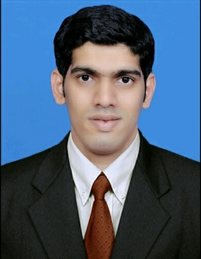

RAHMAT
C/o-Mob. +971505891826
Rahmat.343620@2freemail.com

OBJECTIVE
To seek a position where my education can be fully utilized and where I can grow and contribute towards its growth in a significant manner. I’m lively focused, confident and dedicated with excellent interpersonal and communicative skills. I have a broad outlook and I am experienced in interacting with people of various nationalities. I am fast learner and I’m keen to progress and desirous of developing a career in. I strongly believe that I can contribute positively by joining your dedicated team. [

SUMMER INTERNSHIP
- Final Project: marketing mix
- Company: Pai International, Bhatkal
- Duration: 10 weeks

career skills;
- Marketing Strategies & Campaign.
- Corporate Communications.
- Creative Team Leadership
- Product Positioning & Branding.
- Focus Group & Market Research.
- Development of Training Materials.
- Sales Collateral & Support.
- Public & Media Relations.
- New Product Launch.

EDUCATIONAL QUALIFICATION
Course | Name of collage/school | Board/University | Year of passing
MBA | Anjuman Institute of Technology and  Management | Visvesvaraya  Technological  University | 2016
B.Com | Anjuman Degree  College and PG Centre | Karnataka University Dhardwad | 2012
P.U.C | Anjuman Pre-UniversityCollege | Pre - University Board | 2009
S.S.L.C | Islamia Anglo Urdu  High School | Karnataka Secondary Board | 2006

COMPUTER KNOWLEDGE
- Basic Computer knowledge
- Internet Browsing and Email applications.
- Words, MS Excel.

PERSONAL DETAILS
Date of Birth : 08/04/1989
Sex : Male
Marital Status : Single
Nationality : Indian
Religion : Islam
Languages Known: English, Urdu, Hindi and Kannada

STRENGH

- Sincere, flexible and willing to take more responsibilities.
- Good written and communication skill.
- Willing to learn new skills.
- Meet targets in stipulated duration. Hardworking,
- Self-Motivating and Highly Dedicated.
- Sincerity and Trustworthiness.
- Ability to stay positive.

DECLARATION
All my details in this resume are very true to the best of my knowledge and belief.

Yours Faithfully,

