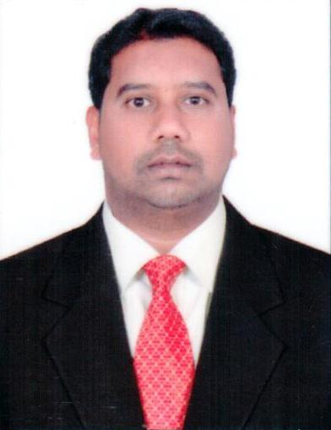
Fareed
C/o-Mobile : +971 505891826
Fareed.343623@2freemail.com
Sharjah, UAE.

CARRER SUMMARY:-

- To be an integral part of a growth driven organization where I can apply my experience of sales and utilize my marketing skills to add value to company’s business and achieve the corporate objectives.
- Having 10 years of Experience in UAE FMCG Market in handling food, Beverages and non food brands.
- Possessing excellent communication and collaboration skills to lead and work in concert with diverse groups effectively
- Adroit at learning new concepts quickly, working well under pressure and communicating ideas clearly and effectively
- Expertise in Sales, Marketing, Business Development, Distribution and Merchandising; knowledge and skill necessary for the satisfactory performance of all assigned responsibilities; ability to relate to people at any level of business and management; Highly ethical, trustworthy and discreet;

Professional Experience:

(i)
Organization | Abuissa Marketing & Distribution - Qatar
Company Profile | Al Rifai nuts, Al Shifa honey, sunbulla, Nivea, supermax and Pert are some of the key products.
Duration | From 07-2016 to 01- 2017.
Designation | Business Development Executive.

Roles &Responsibilities:
- In-charge of total Sales, Receivables and Marketing for all A & B Class clients in the assigned region, with direct reporting to the Sales Manager.
- Built Customer trust and rapport with sincere and excellent sales support.
- Achieved quantitative and qualitative targets assigned.
- Negotiated with the customers on space, promotions, price increases, new listings, etc.
- Ensured the availability of all SKUs in all assigned outlets.
- Provided market intelligence data to concerned managers from time to time
- Monitored stock level at company warehouse.
- Planned and executed promotion activities.
- Ensured Stock rotation.
- Analyzed Daily Sales Report brand wise and outlet wise to achieve the goals accordingly.
- Utilized the opportunities to participate in consumer events with great promotions and offers.

(ii)
Organization | Al Baker Trading, UAE
Company Profile | Gsk , RB and Godrej brands.
Duration | From 2013 to 2015
Designation | Sales Executive.

Roles & Responsibilities:
- Approach each customer with clear ideas and strategy to make the call productive and achieve the set business goals.
- Plan new stands and promotions every month in the assigned outlets to increase sales volume.
- Build Customer trust and rapport with sincere and excellent sales support.
- Closely monitoring the competitor activities to gain new ideas for business development through new promotions and trade deals.
- Rotate the product in other outlets, if the certain product is not moving in one outlet.
- Inform manager and trade marketing team regarding competitor activity in the market and share with them some innovative ideas to drive the sales.
- Allocate the funds to the outlets according to profitability or brand awareness.
- Analyze Daily Sales Report brand wise and outlet wise to achieve the goals accordingly.
- Utilize the opportunities to participate in consumer events with great promotions and offers.

(iii)

Organization | Al Seer Trading Agencies, UAE
Company Profile | One of the leading distributor in UAE and Oman. Dettol, Dabur, Heinz, Huggies and parachute are some of the Key products.
Duration | From 2010 to 2013
Designation | Territory Executive.

Roles and Responsibilities:

- To review monthly sales report and bring about necessary changes in marketing strategies to enhance future sales.
- Monitoring the market and competitors activities.
- Regularly overlook all aspects of sales and collection at regular intervals.
- Forecasting the sales on quarterly and annual basis for the Inventory Management.
- In-charge of total Sales, Receivables and Marketing for all clients in the assigned region, with direct reporting to the Sales Manager.
- Analyze Daily Sales Report brand wise and outlet wise to achieve the goals accordingly.
- Detailed planning for Outdoor/Indoor promotions carried out on regular schedules.

(iv)
Organization | National Trading And Developing Establishment
Company Profile | One of the leading distributor in UAE . Pokka Juices, Al Rabie juices , Cadbury’s are some of the Key products.
Duration | From 2007 to 2010
Designation | Merchandiser.

Roles and Responsibilities:
- Ensuring proper display at all Assigned outlets.
- Deciding how goods should be displayed to maximize customer interest and sales.
- Building up and maintaining product displays.
- Carrying out market research on how well displayed products are moving.
- Accurately stocking and rotating products onto shelves from back stock inventories.
Academic Qualification:
Degree : B.Sc Computer Science
Institution : Andhra University, India

Languages Known:
English Arabic Hindi/Urdu
Personal information:
D.O.B: 01-01-79
Marital Status: Married
Valid UAE driving License

