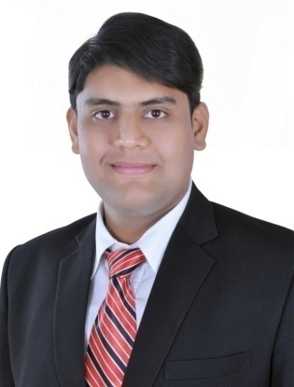
ABDUL

E-mail ID: abdul.343641@2freemail.com
C/o-Mobile: +971 505891826
D.O.B: 31st May 1994
UAE Driving License: YES
Visa Status: U.A.E ResidentVisa

Career Orientation:

I want to achieveSales &Marketing position in a challenging organisation, seeks talented graduate inBTECEdexcel Pearson Qualification in Business Management HND from UnitedKingdom, Englandwith good accounts & business knowledge and experience insame. I am commercially aware & abreast of business and technology affairs & also have gained knowledge about property business in UAE.

Academics: Core Subjects: Marketing, Accounting, Finance &Business

- 2015 - BTEC Pearson Higher National Diploma Business Management Level 05 (Pass)
- Institution Stockton Riverside College - Partnered with Teesside University United Kingdom
- 2012 - HSSC (Commerce) Cambridge System A.K.H.S.S College
- 2010 - Senior schooleducation from His Highness S.M.S Aga Khan School
- 2005 - Primary Education in Boarding school from LAWRENCE College, Murre Hills

Technical Skills:

Strong Command on computer skills; Graphic Designing /Adobe Photoshop/IOS/Mac & Windows8.1
Fluent in English speaking and understands various accents
Efficient Marketing Management& Sales Strategies
Well versed knowledge about retail business

Project Involvement:

- Working as a volunteer at Al Ahsan Charity Association in Takatof program and actively participating in Ramadan Aman Volunteering Projects Dubai, UnitedArabEmirates2016
- Worked for a well-known property developers in Dubai as a property agent for selling flats and studio apartments in Dubai, UnitedArabEmirates2016
- Completed survey on a British food chain calledTescoGiraffe about customer satisfaction, United Kingdom,2015
- Attended Teesside University in one day workshop forcareerdevelopment held in Tees Valley, United Kingdom,2014
- Conducted survey for peoples satisfaction programmeinUnilever Pakistan,2012

WorkExperience:

2015-till date- BUDGET FZE, DUBAI, UAE-Sales & Marketing Officer

2014 - 2015 - The Dixy Chicken - Guest Expert CSR

2014 - 2015 -PERFECT CHICKEN, UNITED KINGDOM- Customer Service Representative

2013 – 2014 -AKBAR’S RESTAURENT, UNITED KINGDOM - Cashier – Asst. Chef

Career Accomplishments:

Year 2015
President of Student Union at Stockton Riverside College,United Kingdom
Year2012 Worked as a supervisor for Commerce society for arranging guest speaker session at AKHSS, Pakistan

Year2011
Awarded with certificate in Bilingual DebateCompetition at Aga Khan Higher Sec School, Pakistan

Year2010
Completed course of Microsoft Office 07 in Word, Power Point, Excel and Info Path,

Additional Languages:

ENGLISH-HINDI- ARABIC - GERMAN

Other Interests:
Cooking Travelling Photography Research Calligraphy Music

