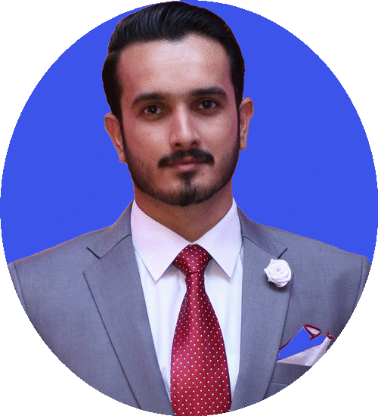[Jawad.343645@2freemail.com](mailto:Jawad.343645@2freemail.com)

MARKETING AND PR

JAWAD

Urdu/ Hindi

MS Word

MS Excel

Internet Marketing

Direct Mail

Promotions

* **Communicating with target audiences and managing customer relationships is always been a priority.**
* Sourcing advertising opportunities and placing adverts in the press or on the radio.
* Keeping and updating customer databases.
* Conducting market research, for example using customer questionnaires and focus groups.
* Contributing to, and developing, marketing plans and strategies.
* Managing budgets and marketing campaigns.
* Monitored and Converted large number of Coke outlets and results were more than the given target and on time.
* Having and building profitable relationships with ad agencies and PR firms.
* Aiding **Marketing Campaigns**.
* Big Results with small marketing Budgets.
* Sales level enhanced by effective product positioning in market leaving behind the competitors shelves.
* Analysing demographic consumers.

**Project:** Analyzing the marketing gaps of newly started company of dairy products **Farm Fresh** in Pakistan. Presented new MarketingStrategies to the company for new market, For Example Improve your B2B / B2C, Market Research, Market Segmentation, Product Launch and Product Positioning etc.

Acquired knowledge about Banking, Finance, Economics and Business Strategies through different subjects and applied this learning in my further education in University and also in my career.

At University Of Gujrat

2009 - 2011

 Pakistan

**Bachelor In Commerce**

At Bahria University, Islamabad

Pakistan



**MARKETING OFFICER**

2012 - 2015

**Master In Business Administration-Marketing**

 EDUCATION

Marketing

CRM

Self-motivated and technically skill PR and Marketing Executive with experience of one year and six months. Excellent organizational and problem-solving skills ensure a streamlined and efficient marketing of organization.

June, 2015-Nov, 2015

At Coca-Cola Beverages pvt LTD

 Pakistan

 Pakistan

Dec, 2015-Nov, 2016

**PR & MARKETING EXECUTIVE**

At Coca-Cola Beverages pvt LTD



English

Marketing Campaigns

Social Media Marketing

Event Marketing

Market Research

 LANGUAGES

 WHY ME?

 SKILLS

WORK EXPERIENCE



CONTACTS

Public Relations