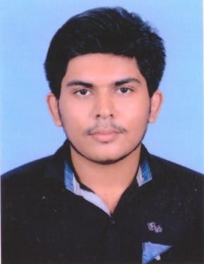
RESUME
MELWIN
C/o-Mob: +971501685421
Email: melwin.343659@2freemail.com

OBJECTIVE
I am seeking for a company where I can utilize my talent and knowledge and which provides career growth along with job satisfaction and accomplishing goals with company’s satisfaction, growth and appraisal.

ACADEMIC QUALIFICATION
- Passed 10th from State Board Kerala with aggregate of 85% in 2007-08.
- Passed 12th from State Board (Commerce) Kerala with aggregate of 68% in 2011-12.
- Bachelor of commerce (Bcom) from University of Calicut.
- Pursuing MBA in FINANCE (2016-17).
- Pursuing CMA (Cost Management Accountant).
- DCFM (Diploma in Computer Financial Management).
- Having basic knowledge of computer.

PERSONAL INFORMATION
GENDER : Male
RELIGION & CASTE : Christian, R.C
NATIONALITY : INDIAN
DATE OF BIRTH : 12TH NOV 1992
MARITAL STATUS : Single
COMPUTER : Word,Excel,Tally etc...
LANGUAGES KNOWN : English, Malayalam, Hindi & Tamil
EXPERIENCE : One year experience as an assistant manager in a private firm

DECLARATION
I hereby declare that information furnished above is true to the best of my knowledge.

