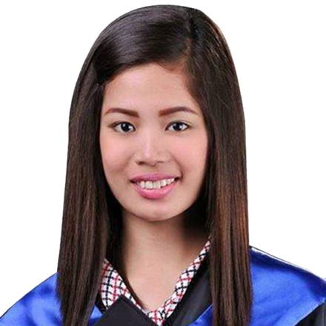
Jasper
Email address: jesper.343665@2freemail.com
C/o-Mobile number : +971505891826

OBJECTIVE:
To obtain a position that would best fit my qualification and develop further my talents and skills for continuous career improvement.

EDUCATIONAL BACKGROUND:

Tertiary : Computer Electronics with Information Technology TESDA AccreditedMinalin Pampanga 2010– 2011
: Bachelor in Secondary Education Pampanga Colleges Macabebe Pampanga 2011 – 2015
Secondary : San Vicente San Francisco National High School San Francisco, Macabebe Pampanga 2009- 2010

SEMINARS and TRAININGS ATTENDED:

October 4, 2013: Seminar in Keeping Up with Times on K to 12 Curriculums
Pampanga Colleges, Macabebe, Pampanga

April 11, 2014: Seminar in Teaching Strategies and Best Practices For Excellent Execution
JILC, San Agustin, City of San Fernando Pampanga

November 2014: On the Job Training at Saint Nicholas Academy
Poblacion, Macabebe Pampanga

October 2015: Serminars on how to be an effective sales consultant and how to deal with the customers.

OTHER SKILLS:

- Computer (Hardware/Software/Microsoft Office Word, Excel, Power Point)
- Fast learner, Self-motivated, Willing to work overtime and can deliver work under pressure.
- Good interpersonal and public relation skills, eager to learn and explore proficiently.

WORKING EXPERIENCES:

English Teacher – IBT CORE IVOLINE, Clark Field Pampanga
July 2015 – August 2015

Sales Consultant/ Cashier – Stores Specialist, Inc. Estancia mall at Ortigas
September 2015 – November 2016
Calvin Klein Jeans, Calvin Klein Underwear, Dune, Vince Camuto
Customer Service Assistant – Greenhills shopping Mall, San Juan City
November 2016- January 2017

LANGUAGES:
- English
- Filipino

PERSONAL DETAILS:
- Age : 23 years old
- Marital Status : Single
- Date of Birth : January 10, 1994
- Nationality : Filipino
- Religion : Christian
- Availability : Anytime
- Height : 5’4’’
- Weight : 110 lbs
- Visa Status : Visit Visa

REFERENCES:
Available upon request.

I hereby certify that the above information is true and correct to best of my knowledge.

