Favas 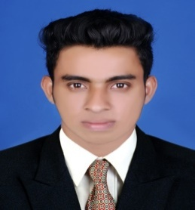
MBA (Marketing&HR)
favas.343681@2freemail.com
C/o- +971505891826

Career Objective
Seeking an entry level position in the field of Marketing and HR.

Executive Summary
MBA in Marketing&HR with 2 year of experience in Sales, Marketing and Business Development.

Handled Dealers and Corporate Sales Successfully.

Worked with Third Eye Security&Home automation Systems as a Marketing&Sales lead and increased Sales from Corporate Clients and dealers.

Increased Sales of Products through Channel Sales and Corporate Sales.

Work Experience

- Third Eye Security&Home Automation systems(Start up)
Co-Founder and Marketing&Sales Lead
Kanhangad, Kerala
Period: Dec2014-Dec2016

Job Responsibilities:

● Plan marketing and branding objectives.
● Expand product solutions and offerings.
● Analyze market trends and recommend changes to marketing and business development strategies based on analysis and feedback.
● Oversee creation and delivery of press releases, advertisements, and other marketing materials.
● Design print ads and publications.
● Ensure brand messages are consistent.
● Engage consumers on social media.
● Deepen relationships with all media to ensure the most effective messaging and positioning of the organization.
● Engage other organizations within the community.
● Develop and lead a marketing team that will develop and execute new concepts, business models, channels andpartners to position business as innovator and leader.

Personal Strength
- Communication Skills
- Confident
- Love to learn new things & detail conscious
- Good managerial skills.
- Optimistic

Educational Qualification
2014 MBA (Marketing & Human Resource) from University of Bangalore, India with 65%.
2012 Bachelor of Arts in travel and tourism management from Kannur university, India with 65%
Computer Knowledge
- Well Versed with MS Office
- Good knowledge of Excel
- Well deserved with all windows platforms

Personal Details
Gender: Male
Date of Birth: 23-Sep-1990
Marital Status: Single
Language Proficiency: English , Malayalam, Hindi ,
Nationality: Indian
Driving License: India , UAE

