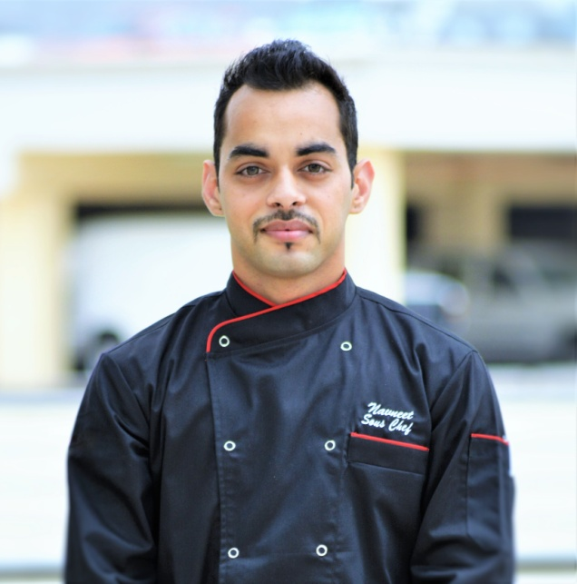

Navneet
C/o- +971503718643
●navneet.343690@2freemail.com
Want to establish myself as a front runner in the field of Service industry & utilize the knowledge to get further experience of globalize work field. With the hard effort & full dedication accomplish everything in best possible manner & work in dynamic & challenging environment.

Passionate about creating new dishes and practicing new food techniques

CORE COMPETENCIES
✔Food costing | ✔ Preopening | ✔ Expert in molecular gastronomy
✔ Recipe costing | ✔ Making recipe cards | ✔ A la Carte operations
✔Fire fighting knowledge | ✔ Quality monitoring | ✔ Assets protection
✔ Take team briefings | ✔ HACCP certified | ✔First aid knowledge
✔ Fine dining plating | ✔ Menu designing | ✔ Banquet experience

PREOPENING EXPERIENCE
Spice and Ice Lounge and Restaurant (Dec 2015 – Apr 2016)
Taj Tower Hotel, Dubai (Jan 2015 – Apr 2015)
The Oberoi Hotel, Dubai (Jan 2015 – June 2015)
WORK EXPERIENCE
Sous Chef - Spice and Ice Lounge and Restaurant Dec 2015 - Present
- Oversight and execution of culinary operations to deliver quality cuisine and create a superb dining experience, thereby ensuring guest satisfaction.
- Collaborate with the Head Chef to forecast and manage menu requirements and inventory for the outlet.
- Manage and train large culinary staff to ensure performance standards are met on a consistent basis.
- Consistently offer professional, friendly and proactive guest service while supporting fellow colleagues
- Ensure the consistency in the preparation of all food items for a la carte.
- Conduct daily shift briefings to kitchen colleagues
- Ensure all kitchen colleagues are aware of standards & expectations
- Liaise daily with Outlet Managers to keep open lines of communication regarding guest feedback
- Maintain and enhance the food products through creative menu development and presentation
- Have full knowledge of all menu items, daily features and promotions
- Actively interact with guests at tables
- Balance operational, administrative and Colleague needs
- Ensure proper staffing and scheduling in accordance to productivity guidelines
- Ensure the cleanliness and maintenance of all work areas, utensils, and equipment
- Follow kitchen policies, procedures and service standards
- Follow all safety and sanitation policies when handling food and beverage
- Other duties as assigned

Chef de Partie (Gastro pub/Peruvian restaurant) – Taj Tower Hotel, Dubai, UAE Jan 2015 – Nov 2015
• Supervises and coordinates activities of cooks and workers engaged in food preparation.
• Supervises kitchen shift operations and ensures compliance with all Food & Beverage policies, standards and procedures.
• Provides services that are above and beyond for customer satisfaction and retention.
• Manages day-to-day operations, ensuring the quality, standards and meeting the expectations of the customers on a daily basis.
• Improves service by communicating and assisting individuals to understand guest needs, providing guidance, feedback, and individual coaching when needed.
• Sets a positive example for guest relations.
• Handles guest problems and complaints.
• Strives to improve service performance.
• Helps employees receive on-going training to understand guest expectations.

Key Achievements
- Achieved level 3 “Person in charge” food safety certificate.
- Awarded ‘employee of the month’ Award for recognition of good work.

Chef de Partie (Garde manger) - The Oberoi Hotel Dubai, Jan 2013 – Dec 2014
- Supervise and check every dish sent from the section to ensure business standards are maintained.
- Responsible for refrigeration cleaning, stock rotation, date coding and section deep cleaning.
- In the absence of the Junior Sous Chef / Sous Chef ensures all checklists and records are completed having checked the work of all responsible colleagues
- In the absence of a senior chef ensure the daily kitchen records and labelling standards are being maintained at all times.
- Manage staff training with the sous chef and maintain an active training plan for each team member.
- Prepare salads, soups, fish, meats, vegetables and other foods.
- Ensure that all stations are set appropriately for a la carte operation.
- Making duty Rotas of the section every week.
• Training staff in molecular gastronomy
• Maintain and ensure the quality of prepared and raw items

Key Achievements
- Achieved Certificate of appreciation for outstanding contribution in preopening of the hotel from general manager.
- Awarded ‘employee of the month’ Award for recognition of good work.
- Awarded as the ‘certified departmental trainer’ from The Oberoi centre of Learning and development.
- Rated as ‘Outstanding’ employee in all job appraisals.

Commis /chef de partie (Garde Manger/Continental kitchen/Butchery)– Trident hotel, Jaipur, India May 2008 – Jan 2013
- Prepare plate and platter presentations for banquets.
- Operate ovens, stoves, grills, microwaves, and fryers to prepare foods.
- Prepare ingredients for cooking, including portioning, chopping, and storing food before use.
- Prepare and cook food. Weigh, measure, and mix ingredients. Wash and peel fresh fruits and vegetables.
- Monitor food quality while preparing food throughout the day. Test food items to determine if they have been cooked sufficiently.
- Ensure the quality of the food items and notify manager if a product does not meet specifications.
- Wash and disinfect kitchen area, tables, tools, knives, and equipment. Set-up and break down work station.
- Check and ensure the correctness of the temperature of appliances and food.
- Follow all company and safety and security policies and procedures; report maintenance needs, accidents, injuries, and unsafe work conditions to manager; complete safety training and certifications.
- Ensure uniform and personal appearances are clean and professional; maintain confidentiality of proprietary information; protect company assets.
- Welcome and acknowledge all guests according to company standards; anticipate and address guests' service needs.
- Speak with others using clear and professional language; answer telephones using appropriate etiquette.
- Develop and maintain positive working relationships with others; support team to reach common goals.
- Ensure adherence to quality expectations and standards.
- Perform other reasonable job duties as requested by Supervisors.

Key Achievements
- Rated as ‘Above target’ employee in all job appraisals.
ADDITIONAL CAPABILITIES
- Strong teamwork skills
- Exceptional sense of guest service.
- Excellent knowledge of culinary deliverance.
- Excellent photography skills.
- Able to work on rotating shifts.

EDUCATION
- Completed “Master degree in Business Administration” from Punjab Technical University, Jalandhar, India in 2010.
- Completed “Bachelor degree in Hotel Management Catering Technology & Tourism” from Agra Institute of hotel Management in 2008.
- Completed Higher Secondary Studies in Science under CBSE Board in 2005.
- Completed High School under CBSE Board in 2003

COMPUTER PROFICIENCY
- MS Office.
- Internet.
- Graphic designing.

PERSONAL INFORMATION

- Date of birth : - 01st January, 1988.
- Sex : - Male
- Nationality : - Indian
- Languages known : - English, Hindi
- Marital status : - Married

