CURRICULUM VITAE

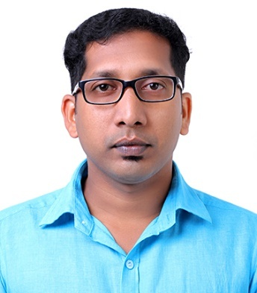

ABDUL
Dubai - UAE
C/o-Mobile: +971502360357
Email: abdul.343725@2freemail.com

OBJECTIVE:

I would like to apply for the vacancy, and enclose my curriculum vitae for your consideration. I am very much interested in this post as I believe that I have the right combination of relevant industrial experience as Mobile Technician and Sales Coordinator experience to not only make an idle candidate, but also a real asset to your company.

ACADEMIC QUALIFICATION:

Course | Board/University | Year of Passing
Diploma | Mobile Phone Repairing | 2006
HSE | State Board of Kerala | 2005
SSLC | State Board of Kerala | 2003

SKILLS:

Sales, Marketing Supervisor, Logistics, Billing, Mobile Repairing, System Troubleshooting,Graphic Designing, Video Editing andInternet Knowledge.

TOOLS USED:

Graphic&Video Editing: AdobePhotoshop, Abode Premiere, Ulead Video Studio.
Operating Systems: Linux, Windows 2000, XP, Vista, Windows 7 and Windows 8.
Office Tools:Microsoft Word, Power Point, Excel.

WORK EXPERIENCE:

- Saudi Electronics.
Duration : June 2014 to July 2016.
Designation : Sales and Supervisor.
Place : Al Balad, Jeddah – Saudi Arabia.

- LULU Hypermarket.
Duration : April 2012 to May 2014.
Designation : Cashier and Supervisor.
Place : Al Khobar, Dammam – Saudi Arabia.

- Cell World Mobile.
Duration : September 2007 to February 2012.
Designation : Senior Mobile Technician and sales.
Place : Kolathur - Kerala (India).

- Bits Mobile Pvt. Ltd.
Duration : June 2006 to August 2007.
Designation : Mobile Technician.
Place : Valanchery –Kerala (India).

PERSONAL STRENGTH:

I am a quick learner. I have great problem-solving skills and I am willing to learn new things to get the job done. Confident and Hard working with well communication skills.

PASSPORT DETAILS:

Date of Issue : 09-06-2010
Date of Expiry : 08-06-2020
Place of Issue : Malappuram

PERSONAL DETAILS:

Date of Birth : 19th March, 1987
Gender : Male
Marital Status : Married
Nationality : Indian
Mother Tongue : Malayalam

LANGUAGES KNOWN:

Arabic, English, Hindi, Tamil and Malayalam.

DECLARATION:

I hereby declare that the above written particulars are true and correct to the best of my knowledge and belief.

