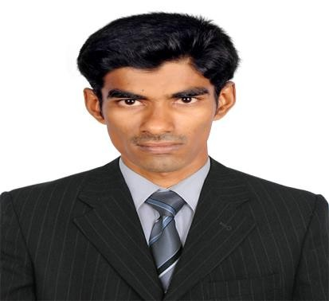
SALEEM
Admin Assistant

saleem.343726@2freemail.com +971505891826

CAREEROBJECTIVE
To utilize my full potential for the organizational escalation which in-turnmakes me to shine as a proficient engineer in the competentenvironment.
PROFESSIONALEXPERIENCE
- Organization: Sutherland Healthcare Solution,Chennai.
- Experience : 2 YearsfromOctober2014toNovember2016.
- Designation : Admin Assistant - ProviderServices.
- Majorrole : Handling Health care services and Medical Bio-data of USClients.
ROLES &RESPONSIBILITIES

ELIGIBILITY VERIFICATION, CLEARING EDITS& DENIALMANAGEMENT:

- Managed the team target as well as the individualtarget.
- Finding the solutions for the problem, maintaining the process related logs &TAT.
- Follow up with client for the issues & clarification in theprocess.
- Maintaining 100% production as well as quality in quicktime.

INSURANCE CLAIMSANALYSIS

- Handling US healthcare Claims, such as MEDICARE, MEDICAID, BCBS,COMMERCIAL, AUTO INSURANCE including AR analysis & codingverification.
- Check insurance websites to identify the insuranceinformation.
- Check the appropriateness of the insurance information given by the patient if itis inadequate orunclear.
- Get clarification on insurance coverage in cases, where information provided bythehospital or Doctor’s office isinsufficient.
- Reduce the AR sitting in Self pay bucket by flipping them to appropriateinsurance and work on thesame
- Will be the part of client calls in three days in a week to resolve the projectrelated issues.
- Co-ordinate with team members to identify and resolve project specific issuesandprocedures.

ACADEMICCHRONICLE
Course | Institution | University/Board | Period | Aggregate
MCA | PRIST UniversityEastCampus,Tamilnadu,India | PRISTUniversity, India | 2012-2014 | 79%
BCA | T.U.K Arts andScience College,Tamilnadu,India. | BharathidasanUniversity,India. | 2009-2012 | 69%
HSC | S.I. (B.M.S) Hr, Sec.School, Tamilnadu, India. | StateBoard | 2008-2009 | 68%
SSLC | Kassimia Hr. Sec.School,Tamilnadu,India. | StateBoard | 2006-2007 | 68%

SOFTWAREPROFICIENCIES
- Programming languages : C,C++,java.
- Framework :.NET
- Packages : MS Word, MS Access, MSPowerPoint.
- Platform : WindowsXP,WindowsVISTA,Windows7.

TECHNICALQUALIFICATION
Senior EnglishTypewriting

EXTRA-CURRICULARACTIVITIES
- Achieved awards of “Star of the Month” and “Perfect Attendance Award”inSutherland Healthcare Solution, Chennai. Participated in Code Debugging inAnna University,Chennai.

PRECISECOMPETENCIES
- Teamworker.
- Punctualperson.
- ActiveLearner.

PERSONALPROFILE
- Date ofBirth : 22ndDecember,1991
- Nationality : Indian
- Religion : Islam
- LinguisticProficiency : English & Tamil.

AUTHENTICATION
I hereby assure that the information furnished above is true to the best ofmy knowledge andbelief.

