CURRICULUM VITAE
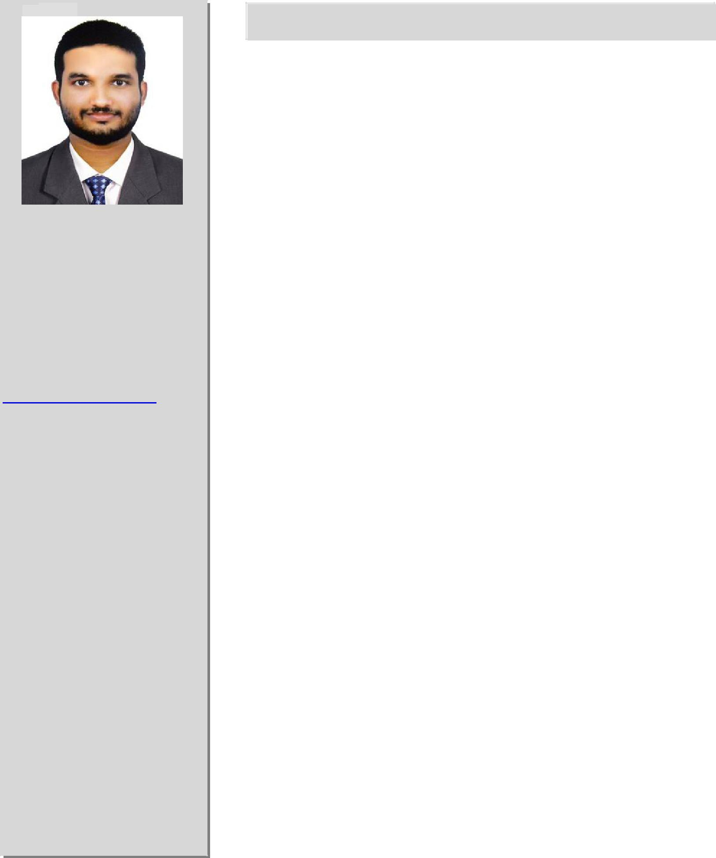

ABDUSSAMAD

Mobile no :

+971-501685421

Email:
Abdusamad.343756@2freemail.com

PERSONAL DETAILS:

Date of Birth:

03/01/1993

Marital Status: Single

Nationality: Indian

C A R E E R O B J E C T I V E :

Seeking a position to utilize my skills and abilities in the industry that offers professional growth while being resourceful, innovative and flexible there by providing value addition to the organizational goals as well as to the nation.

P E R S O N A L A T T R I B U T E S :

- Comprehensive problem solving abilities.

- Excellent verbal and written communication skills.

- Ability to deal with people diplomatically.

- Willingness to learn and ability to adapt to any situation.

- Willingness to share my knowledge with members in a group and confidence to lead the group.

A C A D E M I C C R E D E N T I A L S :

 | Name of the | Year | Percentage
Qualification | Institution/University/Board of | of
 | Examination | Passing

Bachelor’s | TKM COLLEGE OF ENGINEERING |  | CGPA 7.02
degree in
 | KOLLAM | 2015
Mechaical |  |  | (first class)
Engineering | (UNIVERSITY OF KERALA)
 | MIM HSS PERODE | 2010 | 80
12th | (Kerala state Board)
 | MIM HSS PERODE | 2008 | 90
10th | (Kerala state Board)

E X P E R I E N C E

- HVAC Engineer (MEP) at PRIME MEP SOLUTIONS , Calicut, Kerala, India. (June2015 – Present)

1/2

HOBBIES:

Reading Books
Listening to Music
Playing Cricket
Watching Movies

LANGUAGES KNOWN

English
Hindi
Malayalam

TECHNICAL SKILLS:

HVAC JOB RESPONSIBILITIES:

- Heat Load calculations, Heat Loss calculations following ASHRAE Standards.

- Air Distribution System by Velocity Reduction Method, Equal Friction Method and Static Regain Method following SMACNA Standards.

- ESP Calculations for Fans & Blowers.
- Evaporator cooling coil selection.
- Toilet & Kitchen Ventilation system Designing.
- Stairwell pressurization system Designing.
- Car Parking ventilation and fresh air system Designing.
- Head Loss calculation for Primary & Secondary Pump system.

- Chilled water pumps, condenser water Pumps Selection and power calculation.

- Selection of Chillers, AHU’S, FCU’S, Exhaust Fan, Blower, Window Ac Cooling Tower, Desert Cooler and other Equipments.

PLUMBING JOB RESPONSIBILITIES:

- Water Supply Demand following UPC Standards.
- Underground reservoir, Elevated Roof Tank Sizing.
- Water Supply System and Foul Water Drainage System Calculation.
- Vertical Stack, Branch Drain pipe, Horizontal sewer Sizing.

- Manhole, Septic Tank, Soak away pit, Dispersion Trenches Calculation.

- Storm water drainage & External water supply Calculation.
- Garden water supply & fountain designing.
- Head loss Calculation for Water Pipe System.
- Water Pump, Booster Pump, Auto Pneumatic Tank, Fountain Pump Selection.

FIRE FIGHTING JOB RESPONSIBILITIES:

- Fire water Demand & Fire water tank Calculation following NFPA Standards.

- Head Loss calculation for Fire water pumps system.

- Jockey pump, Main Pump, Diesel Operated Pump, and Booster Pumps Selection.

- Sprinkler system, Fire Hose Cabinet, Water Hydrant system, Smoke detector, Heat detector Selection.

- FM 200(Waterless system) Designing and Fire Extinguisher Selection.

C O M P U T E R S K I L L S :

- AutoCAD 2015 , Solid works 2010.

- HAP ( HVAC Design Software).

- McQuay ductsizer, McQuay pipe sizer.

- Languages: Basics of C++.

- FM 200 Pipe sizing, psychometric chart analyzer,

PROJECT AND SEMINAR:

- Main Project: DESIGN AND FABRICATION OF MULTI PURPOSE CHILLED WATER PLANT.

- Seminar: HYDROFORMING TECHNIQUES

D E C L A R A T I O N :

I hereby declare that the above-mentioned information is correct up to my knowledge and I bear the responsibility for the correctness of the above-mentioned particulars.

