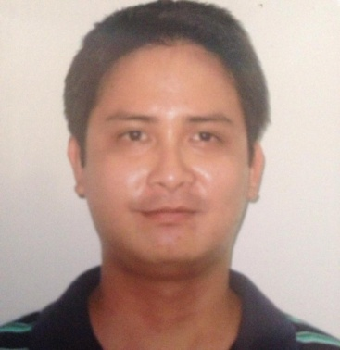
Kevin
C/o- Contact No. +971501685421
Email: Kevin.343770@2freemail.com
____________________________________________________________________________

OBJECTIVE:

To apply in your company and share my knowledge, experience and commitment. To enhance my knowledge and skills to become an asset to your company.

EXPERIENCE:

Clerk , October 2013 – November 2016
Municipality of Cauayan Office
Negros Occidental, Philippines

- File and sort documents according to date and alphabetical order
- Creates paper works depending on the supervisors request.
- Entertains inquiries regarding citizens concerns.
- Answers incoming calls regarding inquiries of the citizens

Data Encoder, June 2012 – September 2013
JRS Business Corporation.
Macaroy Arcade, Guanzon St. Kabankalan City Negros Occidental

- Encodes data regarding daily sales.
- Creates inventory reports for monthly inspection.
- Cretes credit records for partner companies to be submitted every end of the month.
- Checks status of the packages of every customers during inquiry.

Jollibee (Fryman), August 2011 – May 2012
Upper Ground Floor, Gaisano Kabankalan, National Road corner Tan Lorenzo Street, Kabankalan City, 6100, Negros Occidental, Philippines
- In charge of cooking all foods that are fried.
- Maintains the cleanliness of equipment used for frying.
- Checks the quality of the ingredients before cooking.
- Follow standard processes and procedures in handling food.
- Takes note of number of ingredients left to update inventory
- Ensures the quality of the food is up to standard before serving to customers.

EDUCATIONAL BACKGROUND:

HIGHSCHOOL KABANKALAN CATHOLIC COLLEGE

Guanzon Street, Kabankalan City

Negros Occidental

S.Y. 2003-2004

COLLEGE WEST NEGROS UNIVERSITY Bacolod City, Negros Occidental
Bachelor of Science in Nursing
S.Y. 2010-2011

PERSONAL INFORMATION
Age: 29 years old
Date of Birth: September 25, 1987
Place of Birth: Kabankalan City
Gender: Male
Height: 5’5”
Weight: 64 kgs
Nationality: Filipino
Visa: Visit Visa

