Career Objective
Curriculum Vitae

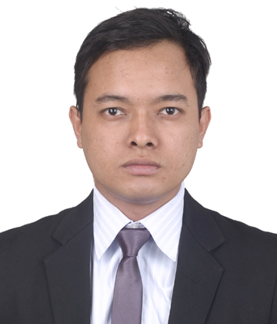
Personal Information:
Name: Indraj
C/o- Number: +971505891826
Email: indraj.343771@2freemail.com
Date of Birth: 27/10/1991

Gender: Male
Religion: Hindu
Nationality: Nepali
Marital Status: Unmarried

Contact Address: Deira Dubai
Language Skills:
Nepali, Hindi, English

Height: 5’7 inch
Weight: 75 kg

Visa Status: Long Term Visit Visa

Extra Activities:
Listening Music, Watching Movies

Passport issue Date: 29/06/ 2011
Passport expiry Date: 28/06/ 2021

Desire to work for an organization with well defined core values bringing in passion, team spirit and desire to obtain results, leading to personal and professional development.
Skills And Competencies

- Good up selling skills, meets and exceeds sales targets
- Decision making and administrative skills
- Planning and forecasting ,proper time management
- Report preparation and presentation
- Familiar with Internet and Email
- Ability to work under pressure
- Positive attitude and Appreciates challenges
- Quick learner can work with minimum management level
- Energetic and hardworking individual
- Experienced in Sales
Academic Qualification

S.N. | Level | Name of Institution | Division | Passed Year
1. | SLC | Nepal Board | 1st division | 2008 AD
2. | +2 | HSEB Board | 2nd division | 2011 AD
3. | Bachelor (BBS) | Tribhuvan University | Pass division | 2016 AD
Work Experience
Experience:
- One year of teaching experience in Small Heaven Boarding School Dharan, Nepal.
- Two years of experience as a Sales Executive in Dev Traders,Honda Showroom, Dharan ,Nepal
Training
Training:
- Basic Computer Course(Ms Excel, Ms Word)
- Tally Course(Accounting)
- Hardware and Networking
- Database Course(Data Entry)
Declaration
Declaration

I hereby declare that the above mentioned particulars are true to the best of my knowledge and belief.

Yours Faithfully
Indraj

