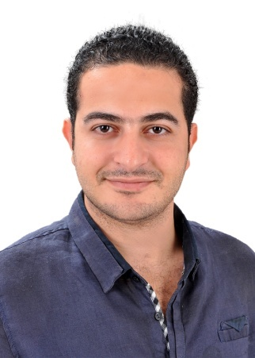
Mostafa
C/o-Mobile no: +971501685421
Email address: mostafa.343772@2freemail.com

Personal information
Date of birth: | 2 of August 1988
Place of birth: | Egypt
Marital Status: | Married
Nationality: | Egyptian
Military Status Exempted

Objective
I would like to use my skills to benefit my employer and in return gain job satisfaction in the Fields of Architecture Engineering. I have good organizational skills, ambitious, self-motivated, target oriented and a team worker.

Scientific Degrees
- BSc of Architecture Engineering.
  - Faculty of Engineering. New Cairoacademy (July 2012)
  - Graduation project grade: excellent
FINISHING THE PRE MASTER FACE
SUBJECT" URBAN SPACES AND ITS IMPACT ON SOCIETY"
At
CAIRO UNIVERSITY
Language Skills
- Arabic (native)
- English (very good, both written and spoken)

Work Experience_______________________________________________________________________________
-Egyptian Canadian Company for Construction (FinishingEngineer and Technical Officer)
      - Compound at El-Obour City, contains 7 villas and 2 swimming pool.
      - Residential Building at Nasr City.
- RAC consulting,Prof. Mohamed RedaAbdallah(Site Supervision - Working Drawing – Photoshop – 3dmax).
    - Site Supervision :-
      - Palace in El-ObourCity,Hardscape and Softscape. (High Quality Finishing)
      - Palace in New Cairo City. Hardscape and Softscape. (High Quality Finishing)
      - Villa at 90 St. New Cairo City. (High Quality Finishing)
      - Villa in Moon Valley Compound. (High Quality Finishing)
      - Residential Buildings at Tayaran Street, Nasr City.
      - Residential Building at ZakerHussien Street, Nasr City.
      - Residential Building at MakramEbeid Street, Nasr City.
      - Residential Building at Abbas El-Akkad Street, Nasr City.
      - Residential Buildings in Sheraton Masr EL-Gdeda. (Two Residential Building)
      - Residential Buildings in Mohandsen. (Two Residential Building)
      - Tito’s Café in Nasr City.
      - Bank Fesial Ismailia.

    - Working Drawing :-
      - Amira Village (Ras Sedr). Redesign the village, urban and building style (working with team)
      - Retag village. Design villas and landscape
      - The headquarters of "Arab Group for Trading and Distribution’. Design
      - Social Housing at October and Suhag, Ministry of Housing. Working with team
      - Four Villa at 90 St. New Cairo City. Design and Shop Drawing
      - Bank Fesial Ismailia. Shop Drawing
      - Factory in El-Obour City. Design and Shop Drawing
      - Apartments in Nasr City and Masr El-Gdeda. Design and Shop Drawing
      - Retail Shops in Nasr City and Masr El-Gdeda. Design and Shop Drawing

- MSC Company for Real Estate Investment in New Cairo City (Site Manager). (CurrentWork)
      - Premium Mall at 90 St. New Cairo City. (High Quality Finishing)

Experiences and Abilities: -
- Obtain the drawings of the project.
- Assess the material and manpower requirement accurately and hand over the material/ manpower requirement to the purchase department to enable procurement, after obtaining approval.
- Assist in preparation of accurate project programs, clearly indicate the timeframes and activities involved in the project and monitor progress against the project plan taking corrective action where required through effective coordination with the client, various types of subcontractors, etc.
- Supervise the site regularly, keep the client updated on the progress of the project and attend to all technical and engineering problems, additional manpower requirements, drawing changes, etc. in an effective and timely manner thereby achieving project requirements and quality standards.
- Organize the site demobilization on project completion and prepare applicable reports.

Trainings and Courses

Aug 2012 Alexandria Construction (TMG)
Cairo, Egypt
Engineer finishes

June2011-sep.2011 Alexandria Construction (TMG)
Cairo, Egypt
Engineer finishes

June2010-Agu2010 Alexandria Construction(TMG)
Cairo, Egypt

AT TALAT MOSTAFA COMPANY. EL REHAB 1 BUILDING (ECGCONSULTANT)

Interpersonal Skills
- Ability to cooperate effectively with colleagues and to work as part of a team.
- Effective communication skills, good presentation skills, creativity and leadership.
- Ambitious and goal-oriented individual.
- Ability to set and achieve goals and to work under pressure.

Computer Skills
- Excellent Knowledge of Ms. Office and Internet.
- Good Knowledge of Photoshop.
- Very Good knowledge of AutoCAD.
- Good Knowledge of 3Ds Max.

Interests
- Playing football, Tennis and Squash
- Traveling & listening to classic music.
- Browsing and searching for new information.

