CURRICULAM VITAE
Post Application For Math's Teacher
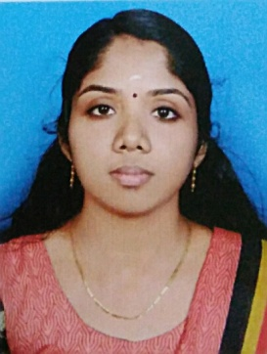 MANJU

Email : manju.343796@2freemail.com
CAREER OBJECTIVE
To secure a challenging position in a progressive organization, where my technical skills can be enhanced and to contribute to the organization success. A person with proven track record of problem solving skills and self motivated player with good communication skills.

ACADAMIC PROFILE

Qualification | University / Board | Year of Passing | % of  Marks
M.Sc (Mathematics) | University of Kerala | 2017 | Result Waiting
B.Ed(Mathematics) | University of Kerala | 2013 | 76.3%
B. Sc (Mathematics) | University of Kerala | 2012 | 63.7%
Plus Two(Science) | Higher Secondary Board of Examination, Kerala | 2009 | 78%
S S L C | Board of Public Examination Govt. of Kerala | 2007 | 81.1%

IT SKILLS
- Languages : C,C++
- Operating Systems : Window Xp, Window 7
- Diploma in Computer Application (DCA).
- Tally ERP 9

WORK EXPERIENCE

- 2 years Experience as a High School Mathematics Teacher in Kerala India.

PROJECT

- TITLE : A STUDY ON DIRICHLET CHARACTERS

PERSONAL DETAILS
Date of birth : 09 June 1991

Sex : Female

Marital Status : Married

Languages Known : Malayalam, English, Tamil & Hindi

Personal Traits : Energetic, Friendly, Social, Hardworking

DECLARATION

I do hereby declare that the above mentioned information is correct up to my knowledge and I bear the responsibility for the correctness for the above mentioned particulars

