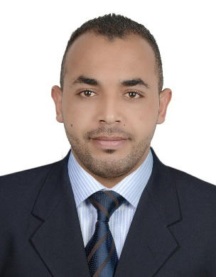
LARBI

Date and place of birth: 02/10/1988 Gafsa (Tunisia)
Marital status: single
Nationality: Tunisian
E-mail: larbi.343805@2freemail.com
Visa employment

SUMMARY
A highly motivated, confident individual with exceptional multi-tasking capabilities and able to work in a target driven, busy cell center environment. Hardworking with excellent attendance and punctuality records who can work equally well alone or as part of a team. Can communicate effectively with people from diverse backgrounds and would be an asset to any employer who respects loyalty and responsibility. Keen to find a challenging position within an ambitious employer where I will be able to continue to increase my work experience & develop my abilities.

AREAS OF EXPERTISE
Customer service, sales, administration and information technologies

WORK EXPERIENCE
Telemarketing acquisition Abu Dhabi commercial bank 06.2016- Present
  - Contact potential or existing customers to inform them about a product or service using scripts
  - Answer questions about products or the company
  - Ask questions to understand customer requirements and close sales
  - Direct prospects to the field sales team when needed
  - Enter and update customer information in the database
  - Take and process orders in an accurate manner
  - Handle grievances to preserve the company’s reputation

Sales representative A.H Banafa group 02.2015 – 05.2016
  - Work with direct clients to sell the products.
  - Evaluate, present and negotiate business opportunities
Outdoors presentations to companies and organizations.
  - Meet clients and build relationships for sales.
  - Visiting Clients continuously for promoting new items or offers.
  - Liaise with all levels in the customer organization as required.
  - Achieve or exceed the allocated sales target
  - Lead Generation
  - Direct Sales
  - Order Processing
  - Customer Service

Call Centre agent Skynet Cargo 01.2014 - 02.2015
  - Obtains client information by answering telephone calls; interviewing clients; verifying information.
  - Determines eligibility by comparing client information to requirements.
  - Establishes policies by entering client information; confirming pricing.
  - Informs clients by explaining procedures; answering questions; providing information.
  - Maintains communication equipment by reporting problems.
  - Maintains and improves quality results by adhering to standards and guidelines; recommending improved procedures

System administrator Linsoft 07.2012 - 06.2013
  - User administration (setup and maintaining account)
  - Maintaining system
  - Verify that peripherals are working properly
  - Quickly arrange repair for hardware in occasion of hardware failure
  - Monitor system performance
  - Create file system
  - Install software
  - Create a backup and recovery policy

.
IT technician MyTech 05.2011 - 09.2011
  - Diagnose computer problems, monitor computer processing systems, install software and perform tests on computer equipment and programs. Set up computer equipment, schedule maintenance and teach clients to use programs. Other job duties can include minor repairs and computer parts ordering
.

EDUCATION
H.I.T.S Bachelor's in information technologies and networks 2008 – 2012

language
Arabic, English and French

