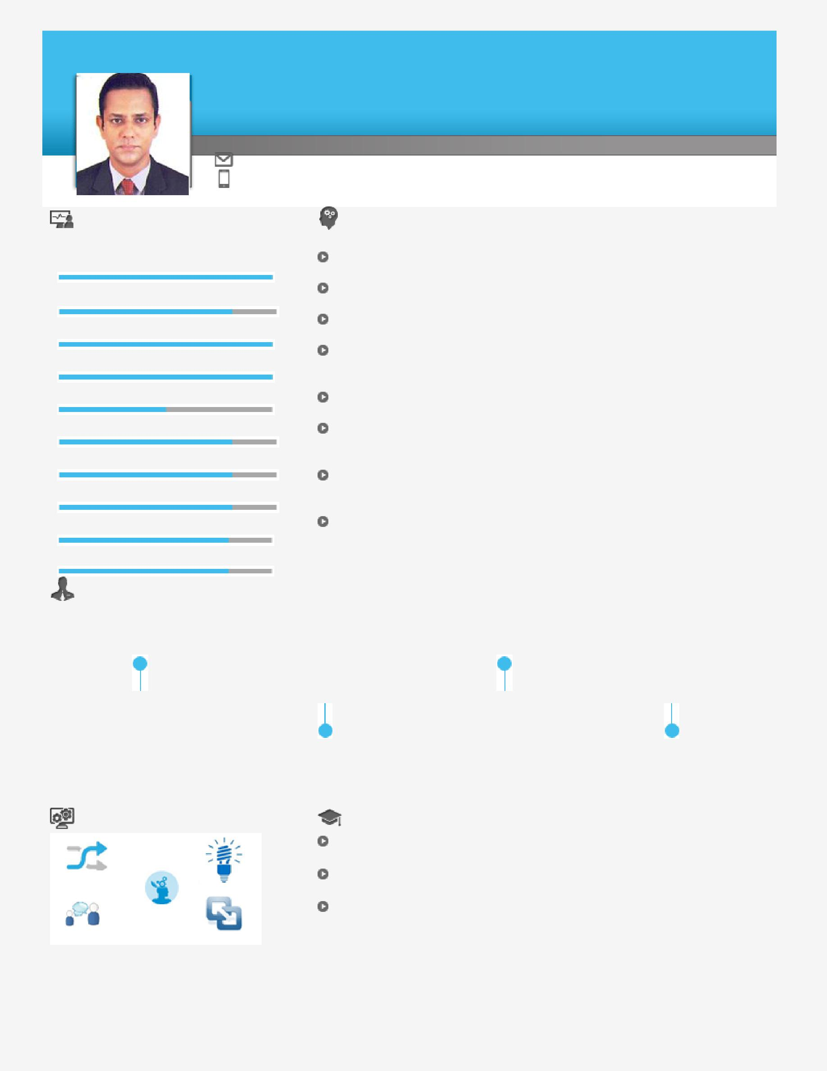
Rakesh

 |  |  |  |  |  | QA/QC Inspector
 |  | Senior-level Professional targeting challenging assignments in Quality Assurance &
 |  | Control with a growth-oriented organisation of repute in Shipping / Marine industry
 |  | Rakesh.343815@2freemail.com
 | Key Skills |  |  |  |  | Profile Summary
 | Quality Assurance & Control |  |  |  |  | QA/QC Senior Welding Inspector with over 21 years of experience
 |  |  |  |  |  | in Shipping & Marine industry
 | Repair & Maintenance |  |  |  |  | Certified Senior Welding Inspector (Level – III); completed Johan
 |  |  |  |  |  | Sverdrup RP Jacket – Aker- Kvaerner Project from Statoil Norway
 | Dry Docking Operations |  |  |  |  | Presently working on Johan Sverdrup Drilling Platform Project from
 |  |  |  |  |  | Norway
 | Structural Fabrication |  |  |  |  | Skilled in implementing preventive techniques to fight corrosion using
 |  |  |  |  |  | periodic hull surveys, correct technique of surface preparation using
 | Client Relationship Management |  |  |  |  | advanced paint schemes & painting techniques
 |  |  |  |  |  | Trained Fire Fighter and Damage Control Instructor on board Naval
 | Crisis and Disaster Management |  |  |  |  | Warships
 |  |  |  |  |  | Experienced in working on sacrificial anodes, care and maintenance of
 | Material Management |  |  |  |  | ICCP (Impressed Current Cathodic Protection) on entire structure of
 |  |  |  |  |  | the ship
 | Team Building & Leadership |  |  |  |  | Expertise in heading the entire logistics function & maintaining smooth
 |  |  |  |  |  | relations with transporters for cost effective transport solutions as well
 | Commissioning of Warships |  |  |  |  | as expeditious clearances
 |  |  |  |  |  | Excellent interpersonal, analytical and negotiation skills with proven
 |  |  |  |  |  | track record of utilizing process-oriented approach towards
 | Ship Construction and Repair |  |  |  |  | accomplishment of cost, profit & organizational goals

 |  | Timeline |  |  |  |  |  |  | Indian Navy as
 |  | Nuclear Biological Chemical |  |  |  |  |  |  | Technical Junior
 |  | Defence and Damage Control |  |  |  |  |  |  | Commissioned Officer
 |  | including Firefighting
 |  | 2004 |  |  | 2015 |  |  |  | Sep’95 – Oct’15 |  | Since Nov’15
 |  |  |  |  | Diploma in |  |  |  |  |  | Dry Docks World as
 |  |  |  |  | Firefighting and |  |  |  |  |  | QA/QC Senior Welding
 |  |  |  |  | Industrial Safety |  |  |  |  |  | Inspector
 |  | Soft Skills |  |  |  | Education
 |  |  |  |  |  | Diploma in Firefighting and Industrial Safety from Royal Institute of
 |  |  |  |  |  | Management Studies, Mumbai in 2015
 |  | Communicator | Innovator |  |  | Nuclear Biological Chemical Defence and Damage Control Including
 |  |  |  |  |  | Firefighting from Indian Navy in 2004
 |  | Thinker |  |  |  | Diploma | in Mechanical Engineering from Navy Shipwright School,
 |  | Collaborator | Intuitive |  |  | Indian Navy under the faculty of Naval Architecture in 1999

Work Experience
Since Nov’15 with Dry Docks World, Dubai as QA/QC Senior Welding Inspector

Sep’95 – Oct’15 with Indian Navy (Defence) as Technical Junior Commissioned Officer Growth Path:

Sep’95 – May’02 : Acting Chief Shipwright – INS Amini
Jun’ 02 – Apr’07 : Chief Shipwright – INS Pralaya (Commissioning crew)
May’07 – Sep’08 : Chief Shipwright – Hull Inspection and Trial Unit.
Oct ’08 – Mar’10 : Junior Commissioned Officer - Ship Building Complex. INS Arihant (India’s 1st Nuclear Submarine)

Apr’10 – Mar’13 : Junior Commissioned Officer - INS Ranvir. In-charge Hull Department
Apr’13 – Oct’15 : Junior Commissioned Officer – INS Matanga. The only ocean going TUG of Indian Navy
Nov’15 – Till Date : Dry Docks World – Dubai – Senior Certified QA/QC Welding inspector

Role:
Conducting in-process and final inspection in shop and onboard and suggesting changes in case of failures on jobs

in compliance with international construction codes, projects specifications and tender work instructions
Attending daily morning meetings onboard; meeting specified requirements, raising occurrence report, developing

corrective & preventive action report

Ensuring the Safety, Quality and Environment Requirements of the yard are strictly followed; attending various professional courses

Working on hull-related equipment, preventive maintenance, defect analysis/ rectification, optimum utilization of a range of mechanical machines tools used onboard ships, aircrafts and industries

Managing wide range of assignments concurrently in a multitude of situations; planning, forecasting, setting objectives and determining courses for preparing in case of eventuality

Supervising works concerning to docking & undocking of ships in grave and floating docks

Checking Dock Blocks in accordance with the Docking Plan prior to Docking; checking the stability and conducting detailed tide calculations

Preparing Dock Floor, maintenance & ballasting / de-ballasting of dock gates and watering & dewatering processes Spearheading construction of Naval Ships in Naval & Commercial Shipyards at various stages of construction Liaising with higher echelons, statutory bodies, vendors and contractors for smooth running of the organization Performing checks on the parameters for acceptability by the Naval authorities based on knowledge about methods of ships construction & ships stability, ships drawing and various systems

Creating the Hull Defect List, Bill of Material and costing for Ships Refit; supervising the refit proceedings at Naval & commercial shipyards for best output

Significant Accomplishments:

Bagged commendation award by the Chief of Naval Command for displaying extreme dedication and exemplary work performance in 2002

Commissioning of frontline Naval Warships.

Purchased commodities, including Fixed and Portable Fire Fighting equipment’s, Vacuum Sanitation (EVAC System), Anchoring equipment’s like Capstan and Windlass, Deck Cranes, Boat Davits, Lifting Appliances, Pneumatic Fenders. and so on.

Ensured timely Dry Docking and Undocking of Naval Warships by completing the entire underwater water Hull package during Refit and annual maintenance

Completed quality projects within time by taking charge on daily inspections, In process inspections and Welding assessment records. Frequent Quality walk rounds.

Implemented several measures like Planned Preventive Maintenance and system called EMAP (Equipment Maintenance and Parameters) to identify deformities, malfunctions or other abnormalities in parts / components / products.

The only Level III senior welding inspector for construction of Johan Sverdrup RP Jacket and now DP Jacket in Dry Docks World – Dubai.

Achieved cost reduction by minimizing the use of consumables by 10% by developing new joint configuration for structural welds

Certifications

CSWIP 3.1 - Certified Welding Inspector, Level II TWI (Cert. No. 87369; valid till May 2019)

CSWIP 3.2.1 - Certified Senior Welding Inspector, Level III TWI (Cert. No. 94005; Valid till September 2019) ASNT NDT Level II - Radiographic Interpretation of Weld Joints
Lead Auditor QMS ISO 9001-2015

IT Skills

MS Office (Word, Excel & PowerPoint)

Windows Operating Systems
Email and Internet Applications

Personal Details
Date of Birth: 19th Jan 1978

Languages Known: English, Hindi and Bengali

Nationality: Indian
Driving License: UAE

Marital Status: Married
No. of Dependents: 03

