Siddhesh
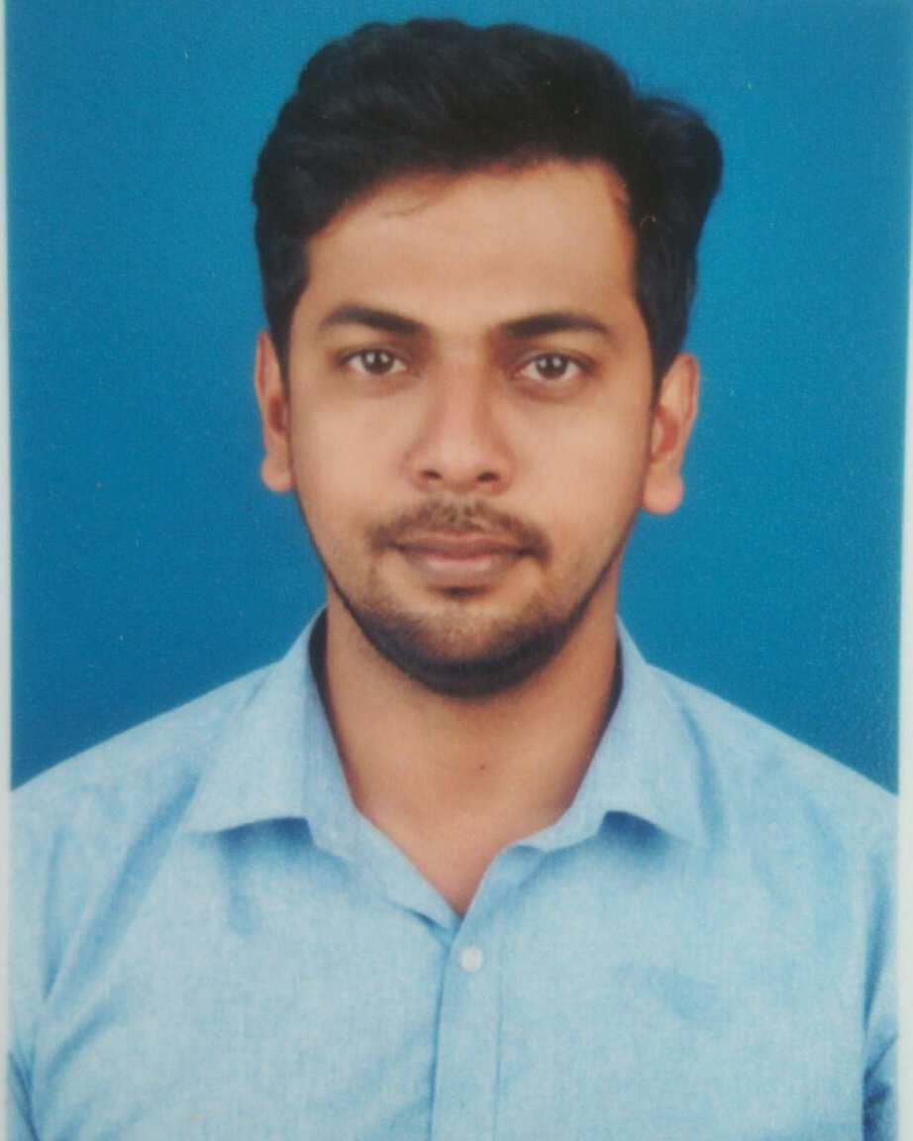
MSc. Botany
Goa University
Email: siddhesh.343820@2freemail.com
C/o-Mobile: +971-501685421

Objective:

Seeking a challenging position to be a significant contributor to the organization to apply my skills and abilities & be innovative for my Career Growth

Job Description:

- 3+ years of experience in phytoplankton identification.
- Proficient in basic lab techniques.
- Good experience in working with Flow cytometer on picophytoplankton.
- Good working knowledge of different types of microscopes.

Job Profile:

Phytoplankton and Picophytoplankton culture and collection of Biological samples –
- Cruise sampling along cochin- Lakshadweep track.
- Daily sampling of estuarine and coastal water for phytoplankton collection.
- Identification of phytoplankton, chlorophyll estimation and isolation and maintenance of Cyanobacteria cultures.

Standard Microbiology Lab procedures -
- Well versed in standard protocols for sterilization, autoclaving, disinfection, staining, plating etc. Culturing micro-organisms from various sources.

Data storage and processing –
- Digitization of analyzed data with graphs and software’s
- Microsoft Excel, Microsoft PowerPoint…etc.

Instrumentations –
- Flow cytometer- FACS Aria II and FACS Verse.
- Microscope – Epifluorescences, Inverted, Compound.
- FlowCam system (Fluid Imaging Technologies Inc.).
- SATLANTIC FIReFluorometer System (Serial No. 03 S).
- Fluorometer (TURNER designs).
- Extraction of pigment samples for HPLC data.
Work Experience / Projects Handled:

Project Assistant at National Institute of Oceanography
From - 1st September 2013 to 30th November 2016
- Recruited under XBT project GAP-2800. Titled - “Observed trends in near surface layer salinity, temperature, depth in Indian waters” (Kochi- Lakshadweep)
- Collection and analysis of biological samples.
- Recruited under BAMPI PROJECT GAP 2429, Titled – “Ballast Water ManagementProgramme “. (Major ports of India).
- Collection and analysis of biological samples collected.

Project Assistant at Goa College of Home Science
From - 1st April2012 to20th August 2013
- Recruited under DSTE Project. Titled - “Documentation, Study and utilization of local plants for natural dyeing ” (North-Goa)
- Collection of natural dye yielding sources.
- Extraction of natural dye and dyeing different type of fabric using standard protocols.
Qualification:

Course | University | Board | Year | Grade
MSc. Botany | Goa University | Goa | 2012 | Second
BSc. Botany | St. Xavier’s. College of Arts, Science & Commerce | Goa | 2010 | Second
H.S.S.C.E | Kamakshi Higher Secondary College of Arts, Science & Commerce. Ponda-Goa | Goa | 2006 | Second
S.S.C.E | A.J.DE Almeida High School. Ponda-Goa | Goa | 2004 | Second

ComputerSkills:

Six month computer programming with MS office, Internet, and basic computing skills

Hobbies:

Reading books, traveling.

Personal profile:

Date of Birth : 15th September 1988
Languages Known : English, Hindi, Marathi and Konkani.
Nationality : Indian.

References:

Available on request

