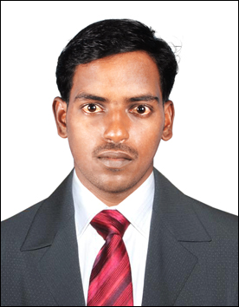
VIGNESH
Al Reef villas,
Abudabi.UAE.
Email: vignesh.343846@2freemail.com

CAREER OBJECTIVE
To work hard with full dedication for the achievement of organization objective under satisfying job contact, hence enhancing my skill and knowledge and ready to learn new things.

EDUCATIONAL PROFILE

Course | Year of passing | Institution | Percentage
B.E  (ECE) | 2010-2014 | K Ramakrishnan College Of  Technology.Trichy | 6.7  (CGPA)
HSC | 2009-2010 | Laurel higher secondary school,  Pattukkottai. | 78.6%
SSLC | 2007-2008 | Vestley matric.higher secondary school,Aranthangi. | 75%

COURSE WORK
- IOSH Training course- working safety (march 2016)
REDHAT SAFETY TRAININ G AND CONSULTING PVT LTD , Chennai.
- International General Certificate in Occupational health and safety (NEBOSH)(march 2016)
. REDHAT SAFETY TRAININ G AND CONSULTING PVT LTD , Chennai.

ACHEIVEMENTS

- I got first place in mini project in my college.
- I got many prizes in schoolings &college.

COMPUTER SKILLS
- Basics of C&C++
- Microsoft office basics

PROJECT PROFILE

MINI PROJECT
Title: “Ultrasonic based object detection”
DESCRIPTION: To detect the object using ultrasonic waves and also used to reduce the accidents.

ACADEMIC PROJECT
Title: “Power transfer without wire using rectenna”
DESCRIPTION: This project is basically used to transfer the power without wire. By
Using rectenna to transfer the power and to reduce the
Connection of wires and also used all electronics goods.

CO – CURRICULAR ACTIVITIES

- Attended Seminar on “High Speed Communication “in Oxford Engg College, Trichy
- Presented a seminar in Satellite communication.
- Attended NATIONAL LEVEL CONFERENCE in K.Ramakrishnan college of technology topic on” Real Time internet protocol using 1500GBPS”

PERSONAL INFORMATION
Date of Birth : 20th August 1992
Marital status : single
Hobbies : Reading Newspapers and listening music
Pass time : Gardening

DECLARATION

I solemnly pledge that the above furnished is true to the best of my knowledge and belief.

Place: Abu Dhabi
Date : 15-2-2017 Yours Sincerely,
S.VIGNESH

