JAMEEL
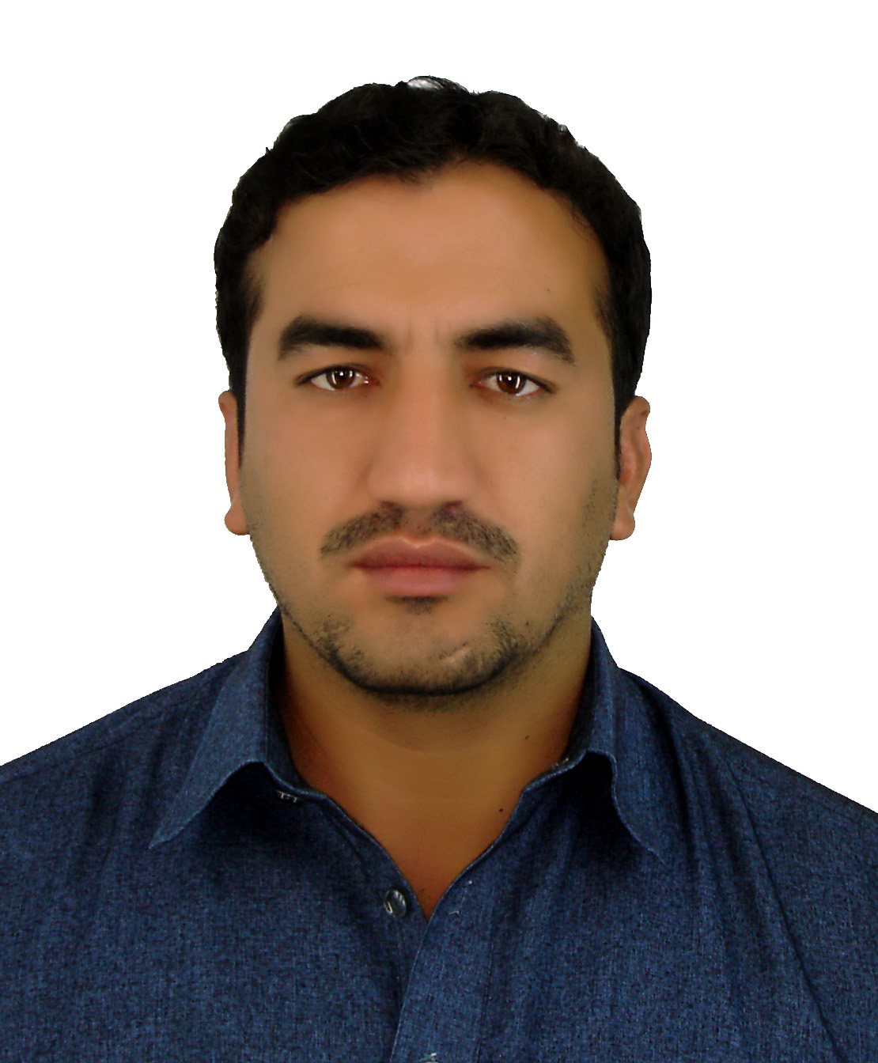

C/o-CCell # 1: +971502360357
Email: jameel.343872@2freemail.com

PERSONAL INFORMATION

  - Date of birth 22 Sept. 1989
  - Religion Islam
  - Nationality Afghani
  - Marital status Married

CAREER OBJECTIVES

- To succeed in an environment of growth and excellence and earn a job which provides me job satisfaction and self-development and help me achieve personal as well as organizational goals and to achieve high carrier growth through a continuous learning process and keep myself dynamic, visionary and competitive with the changing scenario of the world.

EDUCATION

S.NO | Certificate/Degree | Year of Completion | Marks | %age | Board/University
1 | Secondary School Certificate (SSC) | 2008 | 731/900 | 81.2% | Al Hafiz Fazal Public SchoolBISE Kohat KPK Pakistan
2 | Faculty of Science  (FSc(Pre Engineering)) | 2010 | 721/1100 | 65.5% | Government Post Graduate College BISE Kohat KPK Pakistan.
3 | Bachelor of Science in Software Engineering  (Gold Medalist) | 2015 | 3.75 CGPA | 3.75 CGPA | Abasyn University Peshawar KPK Pakistan

SKILLS

- MS Office (MS. Word, MS. Excel, MS. Power point,
MS. Access)
- Visual Programming ( .NET)
- Windows Installation(XP 7,8,10)
- Web Programming Language (PHP, Html, CSS 3,Java script, JQuery ,Ajax)
- Java language
- DatabaseManagement System (MySQL,SqlServer,MS.Access)
- C/C++ (OOP, Data Structure)
- Data communication and Advance computer networking(Cisco Packet Tracer)
- Inpage Software (Pashto, Dari, Urduetc.)
- Adobe Photoshop CS6
- Digital Image Processing (Matlab)
- Basic Computer Hardware

PERSONAL INTEREST

- Searching New Ideas
- Computer Programming
- Computer Games
- Reading Books
- Traveling
- Playing cricket/football
- Doing practical work
- Teaching

SEMINAR/TRAINING

- Attending 3 days “seminar based on peace and conflict issues and youth unity”
held on 9th October 2013 at Peshawar press club.
- Participating 3 days training workshop on “Impossible (I M possible)” held on 7th Nov, 2013 at Abasyn University Peshawar.
- Three days attending “Web Application Development using PHP & MySQL” at Abasyn University Peshawar.
- Participant and Organizer of 3rdAbasyn National Software Competition.

DIPLOMAS/CERTIFICATES

- Six months certificate (computer s/w-16) from Fauji Foundation including (Data Base(MS access),Programming Language(C++),Page Designing(HTML),Data Communication Network etc.
- Three months “Office Automation” Diploma from future vision organization.
- Three months “Hardware” Diploma from future vision organization.
- Two times achieve Certificate of best Academic Achievement certificates.
- Two times my name comes in “The Dean’s List of Honor “award achieves Certificates.
- Achieve certificates of participation of 2ndAbasyn national Software Competition (ANS-14)in Quiz Competition held at Abasyn University Peshawar.
- Achieve certificates of participation of 2ndAbasyn national Software Competition (ANS-14) in Speed Programming held at Abasyn University Peshawar.
- Achieved Gold Medal in software engineering from Abasyn University Peshawar Pakistan.

WORK EXPERIENCE

- Six months work experience as a “Web Developer” from Media Tech Consultants Peshawar Pakistan.
- Design Faisalabad development authority (FDA) website.
- Ideal model school managementsystem ((IMSMGT) and website.
- Simple game develop in C++
- Scientific calculator developed in java language and visual programming language.
- Design database for Tariq holes sale dealer (inventory system) (MS Access).
- Design Mohabbat public school and college kohat website.
- Six months teaching experience in A.Z.M School and College kohatKPK .
- Lecturer in Computer Science Department Preston University Kohatin progress

LANGUAGES

Language | Speaking | Reading | Writing
Pashto | Excellent | Excellent | Excellent
Urdu | Excellent | Excellent | Excellent
English | Good | Excellent | Excellent
Dari | Good | Good | Good

DECLARATION

The above mentioned information is true and correct to the best of my knowledge and belief. If I am selected and given a chance to serve in your esteemed organization I shall prove my best and ability to the entire satisfaction of my superiors.

