Azam

C/o- Mobile+971502360357, E-mail azam.343878@2freemail.co
Profile
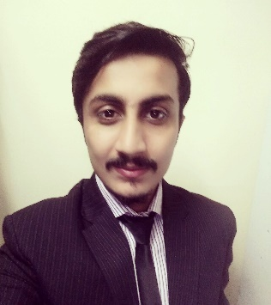 |  |  | Looking for a highly challenging and dynamic work environment in which I will able to enhance my theoretical and technical knowledge and would be able to get valuable work experience and also to discharge my duties up to the entire satisfaction of my superiors.  Looking for a suitable position in the field where my skills and abilities would undoubtedly prove myself as an asset for any organization. The job I seek should contain prospective growth according to my competence.
COMPUTER SKILLS
Skill Name |  |  |  | Level of Expertise | Work Experience | Projects/Tasks
C# Asp.net |  |  |  | Intermediate Level | 8 months | Web & desktop applications development.
PHP |  |  |  | Intermediate Level | 8 months | Websites development
SQL queries |  |  |  | Intermediate Level | 1 year | Writing multiple queries and stored procedures for database handling.
HTML5, CSS, Javascript |  |  |  | Intermediate Level | 1 year | Front end development of web applications.
Adobe Photoshop |  |  |  | Junior Level | 3 months | Editing multiple pictures for the clients.
Adobe Illustrator |  |  |  | Junior Level. | 3 months | Designing banners and posters for the clients.
Software testing |  |  |  | Intermediate Level | 1 year | Run different test cases to check the validity of the software module.
Microsoft Office |  |  |  | Intermediate level | 1 year | Prepare the documents about the tasks and also created proposals for the bidding of new projects
Database Management |  |  |  | Intermediate level | 7 Months | Database Creation , Modification
Professional experience
[November 2015 till January 2016]
Techno-Genes , Lahore , Pakistan

Developer
Major responsibilities included:
- Developed a web application in C# and provided support. It was an Australian project and the application was about sale and purchase of property.
- Wrote SQL queries to link the application with database for the data manipulation
- Provided support for the already developed web application. It was a web application for showing stock exchange market and shares.
- Prepared proposals for the new projects.
- I used to run testing methods to check the validity of the software.
- I used to prepare the sheet of all the tasks which were done at that day.

[May 2016 – November 2016]
Raaziq International (Pvt.) Ltd. Lahore, Pakistan

Developer
Major responsibilities included:
- Customer services representative.
- Work on CRM.
- Running software testing methods.
- Front end developing for web applications
- SQL queries writing for database handling.
- Survey with the marketing team to answer the technical queries asked by
the clients.
- Remove bugs which used to occur in the software.
Educational Qualifications
Degree/ Certificate | Passing Year | Board/University | Major subjects
BSC (Hons) Software Engineer | 2015 | Beaconhouse National University , Pakistan | Data base Management System, Quality, Assurance, Communication Networking, Data Structures
ICS | 2011 | Govt. Islamia college civil lines, Lahore, Pakistan | Physics, Computer, Maths
Matriculation | 2009 | Divisional Public School, Pakistan | Physics, Chemistry, Maths

Personal profile
Date of Birth : 13th July 1992
Nationality & Religion : Pakistani, Islam
Marital Status : Single
Visa Status : Visit
Driving License : Pakistan Driving License
Reference |  |  | Will be available on Request

Language and Sports
Language | - English  - Urdu
Sports | - Football  - Cricket

