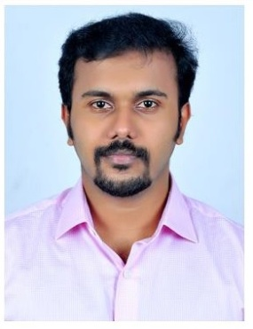
JAISON
Email: jaison.343902@2freemail.com

OBJECTIVE
- To make use of my skills, creativity and experiences for the benefit of the organization I am working with and also to earn my livelihood.

- To devote my time and talent to excel in this field and make genuine and worthy contributions to it through my creative skills.

WORKEXPERIENCE
- Oraganisation Mizpha Dental Clinic, Enathu, Kerala
- Tenure 16 March 2015-3 january 2017
- Position Held Dental Surgeon
- Responsibilities
- Providing professional dental service and care to patients .
- Examining a patients teeth and diagnosing their dental conditions.
- Filling cavities, examining x rays, straightening teeth and repairing fractured teeth, tooth extraction, root canal treatment,tooth replacement
- Updating a patients medical records.

- Organisation Chittur Dental Care Orthodontic & Implant Centre
- Tenure 27 May 2014-14 March 2015
- Position Held Dental Surgeon
- Responsibilities
- Dealing with routine appointments and check ups, taking impressions etc.
- Providing professional dental service and care to patients .
- Examining a patients teeth and diagnosing their dental conditions.
- Updating a patients medical records.
- Filling cavities, examining x rays, straightening teeth and repairing fractured teeth, tooth extraction, root canal treatment ,tooth replacement

- DHA : qualified(Ref:DHA/LS/3182016/637044)
Date:04-12-2016

EDUCATIONAL QUALIFICATION
- Qualification : Bachelor of Dental Surgery (B.D.S.)
Institution : KMCT Dental College, Kozhikode, Kerala.
Passout Year : 2014(including 1 year Internship)
- Qualification : PlusTwo (XII)
Institution : Govt HSS, Kulakkada, Kerala.
Passout Year : 2007
- Qualification : High School (X)
Institution : Govt. VHSS, Kulakkada, Kerala.
Passout Year : 2005

PERSONAL PROFILE

Name : Jaison John
Date of Birth : 02April 1989
Father’s Name : : John Y
Nationality : Indian
Religion : Christian

ADDITIONAL SKILLS

Excellent Communication.
Perform Best in Team.
Languages know: English, Malayalam ,tamil,hindi

DECLARATION
I hereby declare the provided information is true and correct to the best of my knowledge and belief

Place: ALQUSAIS Jaison

