JAISANKAR M.E., 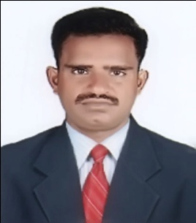
C/o-Ph: +971502360357
jaisankar.343920@2freemail.com
Professional summary
To work in the more challenging position with an organization that provide amble opportunities to learn and contribute.
Skills
- Coordination Telecommunication
- Complex problem solving Computer and electronics
- Installation Economics and Accounting
- Equipment maintenance Disciplined and hardworking
- Leadership and management

Experience
System administrator jan2015 to 2017
GPS COMMUNICATION-perambalur-TN
Security system admin and training engineer jan2014 to 2015
PALVISION technology- perambalur,TN
System service engineer feb2007 to 2014
ESSA SOFT SOLUTIONS-perambalur,TN.
- Maintain systems for instructions or denial of service attacks and report security breaches to appropriate personal.
- Backup or modify applications and related data to provide for disaster recovery
- Test backup or recovery plans regularly and resolve any problems.
- Assisted in the morning and reporting on website traffic and performance
- Worked with clients to analyze computing and network needs and installed appropriate solutions with in each organizations budgets.
Education
M.E.computer science and engineering jun2010
Vmkv engineering college-salam,TN.
B.E computer science and engineering jun2005
Roever engineering college-perambalur-TN.
Higher secondary –maths,biology may2001
Govt higer secondary school, perambalur.
Highschool diploma apr1998
Govt high school,veppanthattai,TN.
PERSONAL PROFILE
Date of birth : 02nd feb 1982
Gender : Male
Marital status : married
Nationality : Indian
Languages : English, Tamil& Malayalam
DECLARATION

I here by declare the above give particulars are true to the best of my knowledge.

