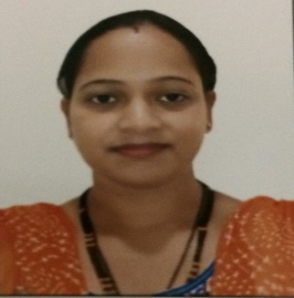
Mrs. Nikeeta
Nikeeta.343929@2freemail.com
_____________________________________________________________________________________

CAREER OBJECTIVE
Looking forward for a challenging career in an organization where there is an ample scope of learning and that gives me scope to apply my knowledge, assume responsibility and Strive for collective growth and development of organization.
Work Experience in India
- Worked as Trainee under Chartered Accountant (CA) for 2 years from December 2008 to December 2010.

JOB RESPONSIBILITIES

- Entering Purchase, Sales, Debit Note, Credit Notes in Tally.
- Entering Bank Statements.
- Bank Reconcilation.
- Issuing FORM C’
- VAT and Sales Tax Retruns.
- Income Tax Returns.
- Worked as Junior Accountant in M/s. PETALS INNOVATIVE MACHINES PRIVATE LIMITED (Manufacturing of Pharmaceutical Capital Machinery And Spares parts) from February 2011 to November 2016.

JOB RESPONSIBILITIES
- Handling all Books of Accounts.
- Looking after Purchases and Sales.
- Preparing Sales Invoices, Delivery Challans.
- Looking after Petty Cash, Daily and Monthly expenses.
- Handling ledger accounts and keeping the check for any invoices or payments
- Bank Statements entries in Tally.
- Bank Reconciliation.
- Looking after Loans and Advances.
- Issuing FORM C’
- Looking after Excise Returns and all Excise related matters.
- Preparing Export Documents as per Letter Of Credit (LC) like: Commercial Invoice, Packing list, SDF Form, Export Declaration, Courier Declarations, A.R.E.
- Preparing Salary statements and paying through RTGS and NEFT.
- Looking after ESIC, PF and LWF.
- Looking towards inward and outward of Goods and Material.

EDUCATIONAL QUALIFICATION
- BACHELOR OF COMMERCE FROM Goa University India with Second class.
- H.S.S.C.E. FROM G.V.M’s S N J A Higher Secondary School Goa India with Second Class.
- S.S.C.E FROM Shree Mahalaxmi English High School Goa India with second class.

ADDITIONAL QUALIFICATION
- Diploma in Computerised Financial Accounting from State Directorate of Craftsmen Training with proficiency in MS –Office, Internet, Tally 7.2 and Tally ERP 9.0.

Key Skills
- Good analytical and problem solving skills.
- Excellent ability to sort, check, count and verify numbers.
- Strong ability to use an automated accounting system.
- Good organizational skills.

PERSONAL DETAILS
- Age : 29 Years
- Date of Birth : 03rd November 1987
- Nationality : Indian
- Status : Married
- Visa Status : Husband’s Visa

I hereby certify that the above mentioned information is true and correct to the best of my knowledge and expertise.

