KHAQAN
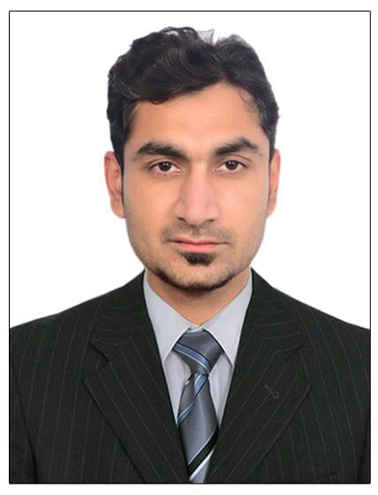
C/o-Contact: +971-504973598
Email: khaqan.343953@2freemail.com

CAREER SUMMARY:

To perform at my level best in a challenging and active environment, where I can prove myself as a dynamic part of that environment. My goal is a long-term association with a strong and growing organization, which appreciates knowledge, dedication and hard working.

EDUCATION:

Degree : Bachelor of Commerce (Honors) / Master of Commerce
Completion Year: 2011
Institution: Hailey College of Commerce
University of The Punjab, Lahore, Pakistan

Degree : Diploma in Commerce
Completion Year: 2006
Institution: Punjab Board of Technical Education, Lahore, Pakistan

Degree: Matriculation (Science)
Completion Year: 2004
Institution: Board of Intermediate & Secondary Education, Gujranwala, Pakistan

EMPLOYMENT HISTORY:

- Company Name: B&B Food Industry
Location: Gujranwala, Pakistan
Position: Accountant
Duration: 01, Oct, 2012 – 15, Dec, 2016
Key Responsibilities:
- Perform all accounting functions related to accounting cycle
- Daily cash posting in subsidiary ledgers
- Prepare invoices of customers
- Experience in preparing of monthly bank reconciliation statements
- Expertise in preparing of sales summaries
- Perform monthly cash audit and inventory count
- Ensuring all books of accounts are maintained properly

- Monitored and record all company expenses
- Expertise in reconciliation of receivables & payables with their respective statements
- Provide all details and information required to facilitate the auditing process
- Maintain material consumption and stock reports
- Debtors and creditors reconciliations
- Expertise in preparation of monthly schedule
- Involved in preparing of monthly management accounts.

COMPUTER SKILLS:

- Microsoft Office
- Strong in ERP softwares (Tally EPR.9 and Peachtree)
- Hyper Text Markup Language (HTML)
- Java Script
- Cascading Style Sheet (CSS)
- Internet Utilities

PERSONAL SKILLS:

- Self motivated and can act on own initiative
- Can quickly learn in a consultative and complex industry
- Excellent negotiation and problem solving skills
- Flexible with working hours
- Adaptable and have a positive attitude towards change
- Motivated, persuasive and goal orientated
- Attention to detail.
- Able to work under pressure
- Open minded and non-judgmental
- Excellent organizational and co-ordination skills

LANGUAGES:

Urdu
English

PERSONAL INFO:

Date of Birth: 29th Dec, 1988
Marital Status: Single
Nationality: Pakistani

