CURRICULUM VITAE

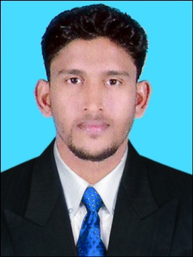

NOUSHAD

E-MAIL noushad.343956@2freemail.com
C/o-PHONE +971504973598

Objective:

To utilize my knowledge and skills in the challenging environment of Marketing Sector - to facilitate the growth of the organization and to identify the prospects for career growth through which the firm may get the maximum advantage.

Education:
- B.Com Co-operation
Calicut University
- Higher Secondary
Kerala Board of Higher education
- SSLC
Kerala Board of Higher education
- IELTS

5.5

Skills:

- Written and communication skills.
- Ability to deal with people diplomatically.
- Excellent interpersonal and applicant assessment skills.
- Proficient in Computers skills like accounting software tally.
- Goal oriented and competent.
- Dedicated and Hardworking, with leadership Qualities.
- Excellent Customer relationship management.
- Tolerant and flexible to different situations.

Technical Skill:
  - Well knowledge in Tally.
  - Post Graduate Diploma in Indian and Foreign Accounting

Accounting Softwares:

- Accounts Management :Tally.ERP 9.0
- Inventory Management :MOS Certification in Ms-Excel
- Tax Management :Peachtree
- Payroll Management :Intuit Certification in QuickBooks
- MIS Reporting :MYOB

Personal Details:
DOB : 23/6/1992
Visa Status : On Visiting
Expiry date : May Fifth
Date of issue : 13/11/2015
Place of issue : Cochin

Languages known English
[ Speak, write and read]
Malayalam
[speak, write and read]

Hobbies Playing football & Travelling

